ACESS - ADAPTIVE COGNITIVE & EDUCATIONAL SKILL SUPPORT PLATFORM

MUHAMMAD ALIFF BIN AFFANDI

UNIVERSITI TEKNIKAL MALAYSIA MELAKA

ACESS - ADAPTIVE COGNITIVE & EDUCATIONAL SKILL SUPPORT PLATFORM

MUHAMMAD ALIFF BIN AFFANDI

This report is submitted in partial fulfillment of the requirements for the Bachelor of Computer Science (Software Development) with Honours.

FACULTY OF INFORMATION AND COMMUNICATION TECHNOLOGY UNIVERSITI TEKNIKAL MALAYSIA MELAKA

2026

DECLARATION

I hereby declare that this project entitled
ACESS - ADAPTIVE COGNITIVE & EDUCATIONAL SKILL SUPPORT PLATFORM
is written by me and is my own effort and that no part has been plagiarized without citations.



STUDENT : Date : 25/6/2026
(MUHAMMAD ALIFF BIN AFFANDI)

I hereby declare that I have read this project report and found this project report is sufficient in term of the scope and quality for the award of Bachelor of Computer Science (Software Development) with Honours.

SUPERVISOR : Date : 25/6/2026
(TS. DR. ZURAINI BINTI OTHMAN)

DEDICATION

To my beloved parents, whose endless sacrifices and unwavering faith have been my foundation through every challenge. To Ts. Dr. Zuraini Binti Othman, whose mentorship and invaluable guidance shaped not only this research but also my growth as a researcher and software developer. To all neurodivergent learners who navigate a world not yet built for them, may ACESS serve as a small step toward a future where educational platforms adapt to every mind rather than demanding that every mind adapt to them.

ACKNOWLEDGEMENT

I would like to express my sincere gratitude to my supervisor, Ts. Dr. Zuraini Binti Othman, for her invaluable guidance, constructive feedback, patience, and continuous support throughout the development of this project. Her expertise, encouragement, and commitment to academic excellence have been instrumental in the successful completion of this research.

I would also like to extend my heartfelt appreciation to my family for their unwavering love, understanding, and encouragement throughout my studies. Their constant support provided me with the strength and motivation to overcome challenges encountered during this journey.

My sincere thanks are also extended to my friends and peers for their assistance, encouragement, and valuable discussions, which contributed to the successful completion of this project. Finally, I would like to acknowledge all individuals who directly or indirectly contributed to this research and supported me throughout the development of the ACESS platform.

ABSTRACT

Traditional e-learning platforms are commonly designed using a one-size-fits-all approach, creating accessibility challenges for neurodivergent learners, particularly those with Dyslexia, Attention Deficit Hyperactivity Disorder (ADHD), and Autism Spectrum Disorder (ASD). Existing learning management systems often provide limited support for diverse cognitive needs, resulting in increased cognitive load and reduced learning effectiveness. This project presents the design and development of the Adaptive Cognitive and Educational Skill Support (ACESS) platform, a web-based learning management system that incorporates adaptive accessibility features to support learners with different cognitive profiles. The project adopts the Agile Scrum methodology, involving iterative planning, analysis, design, and development activities. The system is implemented using Next.js, Supabase, PostgreSQL, and Tailwind CSS to provide a scalable and responsive learning environment. Key features include configurable accessibility profiles, a focus-oriented learning interface, adaptive content recommendations, and educator analytics for monitoring learner progress. The outcomes of this project demonstrate the feasibility of integrating accessibility and adaptive learning mechanisms into a single platform, providing a foundation for a more inclusive and supportive digital learning environment for neurodivergent learners.

ABSTRAK

Platform e-pembelajaran tradisional lazimnya direka menggunakan pendekatan satu-saiz-untuk-semua, yang mewujudkan cabaran kebolehcapaian kepada pelajar neurodivergen, terutamanya mereka yang mengalami Disleksia, Attention Deficit Hyperactivity Disorder (ADHD), dan Autism Spectrum Disorder (ASD). Sistem pengurusan pembelajaran sedia ada sering menyediakan sokongan yang terhad terhadap keperluan kognitif yang pelbagai, sekali gus meningkatkan beban kognitif dan mengurangkan keberkesanan pembelajaran. Projek ini membentangkan reka bentuk dan pembangunan platform Adaptive Cognitive and Educational Skill Support (ACESS), iaitu sebuah sistem pengurusan pembelajaran berasaskan web yang mengintegrasikan ciri kebolehcapaian adaptif untuk menyokong pelajar dengan profil kognitif yang berbeza. Projek ini menggunakan metodologi Agile Scrum yang melibatkan aktiviti perancangan, analisis, reka bentuk, dan pembangunan secara berulang. Sistem ini dibangunkan menggunakan Next.js, Supabase, PostgreSQL, dan Tailwind CSS bagi menyediakan persekitaran pembelajaran yang responsif dan berskala. Ciri-ciri utama termasuk profil kebolehcapaian yang boleh dikonfigurasi, antara muka pembelajaran berorientasikan fokus, cadangan kandungan adaptif, serta analitik untuk membantu pendidik memantau kemajuan pelajar. Hasil projek ini menunjukkan bahawa integrasi mekanisme kebolehcapaian dan pembelajaran adaptif dalam satu platform adalah berpotensi untuk mewujudkan persekitaran pembelajaran digital yang lebih inklusif dan menyokong keperluan pelajar neurodivergen.

TABLE OF CONTENTS

PAGE

DECLARATION ii
DEDICATION iii
ACKNOWLEDGEMENT iv
ABSTRACT v
ABSTRAK vi
TABLE OF CONTENTS vii
LIST OF TABLES x
LIST OF FIGURES xii
LIST OF ABBREVIATIONS xiii
CHAPTER 1: INTRODUCTION 1
  - Background of Study 1
  - Problem Statement 2
  - Objectives 2
  - Scope 3
    - Target Users 3
    - Core System Modules 4
  - Significance of Project 5
  - Expected Output 5
  - Conclusion 6
CHAPTER 2: LITERATURE REVIEW AND PROJECT METHODOLOGY 8
  - Introduction 8
  - Theoretical Frameworks for Cognitive Accessibility 8
    - Universal Design for Learning (UDL) 9
    - Web Content Accessibility Guidelines (WCAG) 2.2 9
  - Neurodivergent Profiles and Interface Interventions 10
    - Attention Deficit Hyperactivity Disorder (ADHD) 10
    - Dyslexia 11
    - Autism Spectrum Disorder (ASD) 11
  - Comparative Analysis of Existing LMS Platforms 11
    - Moodle 12
    - Canvas LMS 12
    - Blackboard Learn 12
    - Google Classroom 13
  - Comparison Matrix 13
    - Alternative Approaches and Justification 13
  - Project Methodology 15
  - Project Requirements 16
    - Software Requirements 16
    - Hardware Requirements 17
    - Other Requirements 18
  - Project Schedule and Milestones 18
  - Summary 20
CHAPTER 3: SYSTEM ANALYSIS 21
  - Introduction 21
  - Problem Analysis 21
    - Current System Scenario 21
    - Detailed Problem Breakdown 22
  - Requirement Analysis 23
    - Data Requirement 23
    - Functional Requirement 24
    - Non-Functional Requirement 28
    - Others Requirement 30
  - System Architecture 31
    - Context Diagram 31
    - System Architecture Diagram 33
    - Deployment Diagram 35
  - Module Design 36
  - Summary 36
CHAPTER 4: SYSTEM DESIGN 38
  - Introduction 38
  - High-Level Design 38
    - Behavioral Design (Activity Diagrams) 38
    - Interaction Design (Sequence Diagrams) 45
    - User Interface Design 49
    - Database Design & Entity Relationship 52
  - Comprehensive Data Dictionary 54
    - Core Identity and Configuration 54
    - Curriculum Structure 58
    - Telemetry and Assessment 64
    - Learner Progress and Checkpoints 67
    - Content and Media 68
  - Detailed Design 73
    - Software Design 73
    - Physical Database Design 77
    - Systemic Implementation Details 79
  - Summary 80
References 81

LIST OF TABLES

PAGE
Table 2.1 LMS Feature Comparison Matrix 14
Table 2.2 Project Schedule and Milestones 19
Table 3.1 Functional Requirements: Student Module 26
Table 3.2 Functional Requirements: Educator Module 27
Table 3.3 Functional Requirements: Admin Module 27
Table 4.1 Users Data Dictionary 54
Table 4.2 User Profiles Data Dictionary 55
Table 4.3 User Accessibility Preferences Data Dictionary 55
Table 4.4 Enrollments Data Dictionary 56
Table 4.5 Accessibility Templates Data Dictionary 56
Table 4.6 Adaptive Interactions Data Dictionary 56
Table 4.7 Instructor Applications Data Dictionary 57
Table 4.8 Password Reset Tokens Data Dictionary 57
Table 4.9 Referral Codes Data Dictionary 58
Table 4.10 Courses Data Dictionary 59
Table 4.11 Lessons Data Dictionary 60
Table 4.12 Quizzes Data Dictionary 61
Table 4.13 Quiz Questions Data Dictionary 61
Table 4.14 Quiz Options Data Dictionary 61
Table 4.15 Course Chapters Data Dictionary 62
Table 4.16 Course Milestones Data Dictionary 62
Table 4.17 Course Achievements Data Dictionary 63
Table 4.18 Course Accessibility Categories Data Dictionary 63
Table 4.19 Course Favorites Data Dictionary 63

Table 4.20 Quiz Attempts Data Dictionary 64
Table 4.21 Quiz Answers Data Dictionary 64
Table 4.22 Lesson Progress Data Dictionary 65
Table 4.23 Lesson Checkpoints Data Dictionary 65
Table 4.24 Learner Checkpoints Data Dictionary 66
Table 4.25 Learner Milestones Data Dictionary 66
Table 4.26 Video Questions Data Dictionary 67
Table 4.27 Recommendations Data Dictionary 67
Table 4.28 User Achievements Data Dictionary 68
Table 4.29 Lesson Comments Data Dictionary 68
Table 4.30 Lesson Summaries Data Dictionary 69
Table 4.31 Lesson Versions Data Dictionary 69
Table 4.32 Lesson Interactive Content Data Dictionary 70
Table 4.33 Lesson Templates Data Dictionary 70
Table 4.34 Media Assets Data Dictionary 71
Table 4.35 Notifications Data Dictionary 71
Table 4.36 Contact Messages Data Dictionary 72
Table 4.37 Certificates Data Dictionary 72
Table 4.38 Certificate Templates Data Dictionary 73
Table 4.39 Certificate Verifications Data Dictionary 73

LIST OF FIGURES

PAGE

Figure 2.1 | Gantt chart of ACESS development schedule (14 weeks) . . . . . . | 19
Figure 3.1 | Current System Problem Analysis Diagram . . . . . . . . . . . . . | 22
Figure 3.2 | Use Case Diagram for ACESS Platform . . . . . . . . . . . . . . | 25
Figure 3.3 | Context Diagram . . . . . . . . . . . . . . . . . . . . . . . . . . . | 32
Figure 3.4 | System Architecture Diagram . . . . . . . . . . . . . . . . . . . . | 33
Figure 3.5 | Deployment Diagram . . . . . . . . . . . . . . . . . . . . . . . . | 35
Figure 4.1 | Student Activity Diagram . . . . . . . . . . . . . . . . . . . . . . | 40
Figure 4.2 | Educator Activity Diagram . . . . . . . . . . . . . . . . . . . . . | 43
Figure 4.3 | Administrator Activity Diagram . . . . . . . . . . . . . . . . . . . | 45
Figure 4.4 | Course Enrollment Sequence Diagram . . . . . . . . . . . . . . . | 46
Figure 4.5 | Lesson Learning Sequence Diagram . . . . . . . . . . . . . . . . | 47
Figure 4.6 | Quiz Attempt Sequence Diagram . . . . . . . . . . . . . . . . . . | 48
Figure 4.7 | Course Creation Sequence Diagram . . . . . . . . . . . . . . . . . | 49
Figure 4.8 | Database Entity Relationship Diagram . . . . . . . . . . . . . . . | 53

LIST OF ABBREVIATIONS

ACESS - Adaptive Cognitive & Educational Skill Support ADHD - Attention Deficit Hyperactivity Disorder
ERD - Entity Relationship Diagram
LMS - Learning Management System OOAD - Object-Oriented Analysis and Design PSM - Projek Sarjana Muda
RBAC - Role-Based Access Control
TTS - Text-to-Speech
UDL - Universal Design for Learning WCAG - Web Content Accessibility Guidelines

CHAPTER 1: INTRODUCTION

Background of Study

In the current educational landscape, instruction is delivered through a blend of traditional face-to-face classroom settings and online platforms [Prensky, 2001]. While digital tools have become increasingly common to support learning, many institutions still rely heavily on traditional teaching methods. This hybrid approach presents unique challenges for neurodivergent individuals, specifically those with Dyslexia, Attention Deficit Hyperactivity Disorder (ADHD), and Autism Spectrum Disorder (ASD). Whether learning occurs in a physical classroom or online, the tools used to deliver content often lack the flexibility required to accommodate diverse cognitive profiles.

Existing Learning Management Systems (LMS) are typically designed with a “one-size-fits-all” approach. They present dense textual information, complex navigation structures, and rigid assessment formats. These standard interfaces can erect significant barriers for neurodivergent learners. For instance, learners with Dyslexia may struggle with standard typography and line spacing [Franceschini et al., 2013], while those with ADHD might find cluttered interfaces and unstructured learning paths overwhelming [Barkley, 1997].

Therefore, there is a critical need for a natively adaptive learning platform that can seamlessly support both face-to-face and remote learning environments. The Adaptive Cognitive Education Support System (ACESS) is proposed to bridge this gap. ACESS is engineered to provide an inclusive digital learning environment that dynamically alters its interface and content delivery based on the specific cognitive requirements of the user. By integrating features such as dynamic typography adjustment, focus-driven layouts, and

rule-based adaptive learning paths, ACESS aims to ensure that educational materials are accessible and equitable for all learners, regardless of the instructional setting.

Problem Statement

Despite the availability of various educational technologies, significant cognitive accessibility barriers persist. The core problem this project addresses is the systemic inadequacy of current educational platforms to serve learners with disabilities.

Specifically, the problems identified are:

- Most existing e-learning platforms are not designed for learners with disabilities. They use formats that overwhelm cognitive and sensory processing, leading to high dropout rates.
- Learners with disabilities lack platforms that adapt to their individual learning pace and present content in accessible, easy-to-process formats.
- Employers and support organisations have no reliable way to verify the skills gained by learners with disabilities due to the absence of proper progress tracking and accessible certification.
- Educators and mentors do not have a centralised platform to monitor learner progress, identify those who need extra support, and manage accessible learning materials effectively.

Objectives

This project aims to achieve the following objectives:

- To analyze the accessibility requirements, learning challenges, and content delivery needs of learners with dyslexia, ADHD, and mild cognitive impairment

through literature review and comparative study of existing e-learning platforms and assistive technology standards.
- To develop a fully functional accessible web-based e-learning platform that incorporates rule-based adaptive content delivery, built-in Text-to-Speech (TTS) support, adjustable accessibility display settings, structured lesson and quiz management, and role-based user management for learners, educators, and administrators.
- To implement a certificate generation module and an educator analytics dashboard that provide verifiable skill completion records and enable data-driven monitoring of individual learner progress.
- To evaluate the functional correctness, usability, and accessibility of the developed platform through structured walkthroughs and expert review.

Scope

The scope of the ACESS platform defines the boundaries of the system architecture, target users, and core functional modules. The system is designed to act as a supportive educational tool for both traditional and online learning environments.

Target Users

      - Learners: The primary consumers of the educational content. The interface is specifically optimized for neurodivergent individuals, though it remains highly beneficial for neurotypical users.
      - Educators: The course creators and administrators who require structured, intuitive tools to author accessible content, manage media assets, and monitor student progress.
      - Administrators: System operators responsible for platform governance, user role management, and global accessibility configuration.

Core System Modules

The ACESS architecture is divided into the following core modules:

      - Authentication and Profile Module: Manages secure registration, login, role-based access control for learners, educators, and administrators, email verification, password reset, and profile management.
      - Accessibility and Personalization Engine: The central differentiator of ACESS. Stores per-user accessibility preferences defining cognitive profiles with granular controls over font, spacing, theme, focus mode, reduced motion, and text-to-speech. Settings are applied globally, requiring no manual configuration after onboarding.
      - Educator Authoring Module: Provides an interface for creating structured courses with chapters and milestones, writing lessons, uploading video assets with time-coded questions, designing interactive activities, managing lesson version history, and configuring quiz, certificate, and achievement criteria.
      - Adaptive Learning Module: Governs course enrollment, lesson progression, dynamic UI alterations based on accessibility profiles, and personalized recommendations triggered by quiz performance, including a rule-based engine that suggests revision, standard, or advanced content.
      - Interactive Assessment Module: Handles timed and untimed quiz delivery, multiple attempts, automated grading, answer review, and pass/fail threshold evaluation that triggers remedial recommendations when scores fall below configured thresholds.
      - Analytics and Telemetry Module: Tracks engagement metrics such as time per lesson, completion rates, and scores, and provides educators with per-student dashboards with at-risk detection, plus platform-wide analytics for administrators.
      - Certificate and Achievement Module: Generates personalized PDF certificates upon course completion and administers a badge system that awards visual milestones based on predefined criteria to enhance motivation.

      - Interactive Content Module: Supports multiple activity types with dedicated builder and viewer components, plus time-coded video questions and structured content blocks.
      - Communication and Notification Module: Manages threaded lesson discussions, a contact form for inquiries, and a database-triggered notification system that alerts users on enrollment, progress, quiz attempts, lesson additions, and course publication.

Significance of Project

The development of the ACESS platform represents a significant step towards educational equity. By shifting the burden of accessibility from the user to the system architecture, the platform ensures that neurodivergent learners can focus entirely on comprehending the educational material rather than struggling with the interface.

For learners, the project provides a calm, predictable, and highly customizable environment that mitigates anxiety and cognitive fatigue. For educators, it offers a streamlined toolset that enforces accessibility best practices during content creation, alongside deep analytical insights into student engagement. Ultimately, ACESS demonstrates how modern web architecture can be leveraged to create a truly inclusive educational ecosystem applicable in both physical classrooms and remote learning scenarios.

Expected Output

The ACESS platform is expected to produce the following deliverables upon completion:

- Adaptive Web Application: A fully functional, production-ready learning management system accessible via standard web browsers and capable of dynamically adjusting its interface based on user accessibility profiles.

- Role-Based Dashboards: Three distinct interfaces for Learners, Educators, and Administrators, each with tailored navigation, permissions, and tooling appropriate to their respective responsibilities.
- Accessibility Customization System: A comprehensive set of user-configurable accessibility presets covering cognitive profiles, including typography control, theme switching, focus mode, text-to-speech, and reduced motion toggles.
- Adaptive Recommendation Engine: A rule-based engine that automatically analyzes quiz performance and generates personalized lesson recommendations to address identified knowledge gaps.
- Course Authoring Tools: An editor integrated with media upload, interactive activity builders, and content embedding for educators.
- Quiz and Assessment System: A complete assessment lifecycle including timed and untimed quizzes, automated grading, multiple attempt management, and answer review capabilities.
- Analytics Dashboard: Visual engagement metrics and progress tracking with per-student and per-course views for educators, plus platform-wide analytics for administrators.
- Certificate and Achievement System: Automated PDF certificate generation upon course completion and a badge-based achievement system to incentivize learner progress.
- Notification System: Database-triggered real-time notifications for enrollment, quiz results, lesson additions, and course publication across all user roles.

Conclusion

This chapter established the foundational context for the ACESS project by identifying the critical accessibility barriers present in current educational platforms, defining the specific problems to be addressed, and outlining the objectives and scope of the proposed system. The significance of the project was discussed in terms of its potential impact on educational equity for neurodivergent learners, and the expected deliverables were enumerated. The next chapter presents a comprehensive literature review, examining existing theoretical frameworks, analyzing current Learning Management Systems, describing the project methodology, and detailing the software and hardware requirements necessary to realize the ACESS platform.

CHAPTER 2: LITERATURE REVIEW AND PROJECT METHODOLOGY

Introduction

The literature review provides the academic and technical foundation upon which the ACESS platform is conceptualized. This chapter synthesizes contemporary research regarding cognitive accessibility in digital education, evaluates established theoretical frameworks such as Universal Design for Learning (UDL) [Meyer et al., 2014], and rigorously analyzes existing Learning Management Systems (LMS). By comparing platforms like Moodle [MoodleHQ, 2023b], Canvas [Instructure, Inc., 2023], Blackboard [Anthology Inc., 2023], and Google Classroom [Google LLC, 2023] against the specific requirements of neurodivergent learners, this chapter identifies the critical systemic gaps that justify the development of a natively adaptive, rule-based LMS architecture.

Theoretical Frameworks for Cognitive Accessibility

The design of digital interfaces for educational purposes must be grounded in empirically validated frameworks. The two primary pillars supporting the ACESS architecture are the Universal Design for Learning (UDL) guidelines [Meyer et al., 2014] and the Web Content Accessibility Guidelines (WCAG) 2.2 [W3C Web Accessibility Initiative, 2023].

Universal Design for Learning (UDL)

Universal Design for Learning is a framework developed by CAST [Meyer et al., 2014] aimed at optimizing teaching and learning for all individuals based on scientific insights into how humans learn. UDL is predicated on three primary principles:

      - Multiple Means of Engagement: Recognizing that learners differ markedly in the ways they are motivated. For neurodivergent learners, particularly those with ADHD, motivation can be severely hampered by unstructured environments [Barkley, 1997]. ACESS implements this by offering gamified achievements and structured, step-by-step progressive disclosure of course material to prevent cognitive overwhelm.
      - Multiple Means of Representation: Learners vary in how they perceive and comprehend information. A Dyslexic learner may struggle with printed text but excel with audio. ACESS implements this principle via integrated Text-to-Speech (TTS) capabilities and dynamic CSS injection that allows the user to radically alter the typography (e.g., using Atkinson Hyperlegible [Atkinson, 2021]) and contrast ratios.
      - Multiple Means of Action and Expression: Learners differ in how they navigate a learning environment and express what they know. ACESS supports this by providing multiple quiz formats (scenario-based, multiple-choice) and allowing untimed assessments to reduce anxiety-induced performance degradation.

Web Content Accessibility Guidelines (WCAG) 2.2

While UDL provides the pedagogical framework, WCAG 2.2 [W3C Web Accessibility Initiative, 2023] provides the strict, measurable technical parameters for digital accessibility. The ACESS platform targets Level AA compliance. Key WCAG criteria directly addressed by ACESS include:

      - Guideline 1.4.12 (Text Spacing): The ability to override default text spacing (line height, letter spacing, word spacing) without loss of content or functionality. This is a critical requirement for Dyslexia, which ACESS solves via its Tailwind CSS @theme variable injection.
      - Guideline 2.2.1 (Timing Adjustable): Providing users the ability to turn off, adjust, or extend time limits. ACESS allows educators to configure untimed quizzes specifically to accommodate learners requiring extended processing time.
      - Guideline 2.3.3 (Animation from Interactions): Motion animation triggered by interaction can be disabled. The ACESS system implements a global attribute that globally disables all animations, critical for learners prone to vestibular disorders or severe distraction (ADHD).

Neurodivergent Profiles and Interface Interventions

Understanding the specific cognitive challenges faced by the target demographic is essential for architecting effective UI/UX interventions.

Attention Deficit Hyperactivity Disorder (ADHD)

ADHD is characterized by executive dysfunction [Zelazo et al., 2003], impacting working memory, task initiation, and sustained attention [Barkley, 1997]. In digital environments, learners with ADHD are highly susceptible to ”saccadic fatigue,” the exhaustion caused by the eye constantly darting across a busy screen to parse disorganized information [Munoz et al., 2003]. ACESS Intervention: The implementation of a strict ”Focus Mode.” This mode conditionally hides the primary navigation sidebar, the global footer, and all extraneous dashboard widgets when a learner enters a lesson. The content is restricted to a narrow, center-aligned column (maximum 65 characters per line), minimizing required eye movement and drastically reducing peripheral distraction.

Dyslexia

Dyslexia involves difficulties with accurate or fluent word recognition and poor spelling and decoding abilities [Rello and Baeza-Yates, 2013]. Research indicates that specific typographical adjustments can significantly improve reading velocity and comprehension [Franceschini et al., 2013]. ACESS Intervention: The platform abandons reliance on browser-level zoom. Instead, it utilizes React Context to allow the user to select a ”Dyslexia Profile.” This injects CSS variables that alter the global font family to specialized typefaces designed to prevent letter mirroring (e.g., confusing ’b’ and ’d’), increases the base line-height to 1.75, and manipulates letter-spacing (tracking) to prevent visual crowding [Batanero et al., 2014].

Autism Spectrum Disorder (ASD)

Learners on the Autism Spectrum often thrive in highly structured, predictable environments and can experience severe distress when confronted with unexpected auditory or visual stimuli [Lawson, 2011]. ACESS Intervention: The platform enforces strict structural consistency. Educators utilizing the Tiptap rich-text editor [Brainhub, 2024] are prevented from creating chaotic, ad-hoc layouts. Furthermore, the system defaults to suppressing autoplaying media and allows the user to globally toggle a ”Reduced Motion” state, ensuring the interface remains a calm, predictable schedule of events.

Comparative Analysis of Existing LMS Platforms

To justify the development of ACESS, an extensive evaluation of existing market-leading platforms was conducted. The platforms analyzed include Moodle [MoodleHQ, 2023b], Canvas LMS [Instructure, Inc., 2023], Blackboard Learn [Anthology Inc., 2023], and Google Classroom [Google LLC, 2023].

Moodle

Moodle is an open-source powerhouse, widely adopted globally [MoodleHQ, 2023a]. Its greatest strength is its modularity. However, this is also its critical failing regarding cognitive accessibility. Limitations: Moodle’s native interface is notoriously dense and text-heavy. While administrators can install accessibility plugins like the ’Accessibility block,’ these are bolt-on solutions. They require the learner to actively engage with a separate menu to adjust settings, adding cognitive load. Furthermore, Moodle relies on educators to manually identify struggling students and assign remedial work. It lacks a native, real-time heuristic engine to automate this process.

Canvas LMS

Canvas by Instructure represents a more modern, streamlined UI compared to Moodle [Instructure, Inc., 2023]. It utilizes a card-based dashboard that is visually appealing to neurotypical users. Limitations: Canvas achieves basic WCAG compliance but fails to provide deep cognitive accommodations. It lacks native Text-to-Speech, forcing reliance on OS-level tools, and does not offer granular control over typography such as specific Dyslexia fonts or adjusted inter-letter spacing. The platform is highly linear. If a student fails a Canvas quiz, the system cannot automatically restructure the module path to enforce revision.

Blackboard Learn

Blackboard is an enterprise-grade solution focused heavily on synchronous learning integrations and comprehensive grading rubrics [Anthology Inc., 2023]. Limitations: Blackboard’s interface is often criticized for complex, deeply nested navigation menus (often three or four clicks deep to access a specific assignment file). For learners with executive dysfunction (ADHD), this navigational friction is a massive barrier to task initiation. Like Moodle, Blackboard’s accessibility features are largely

reactive (e.g., Blackboard ALLY checks documents for screen-reader compatibility) rather than proactive (dynamically altering the interface for the user).

Google Classroom

Google Classroom is a stripped-down, lightweight system focused on integration with the Google Workspace ecosystem (Docs, Drive, Forms) [Google LLC, 2023]. Limitations: While its minimalist design reduces initial visual clutter, it is too rudimentary to function as a fully adaptive LMS. It completely lacks advanced features such as rule-based learning paths, granular progress telemetry (tracking time-spent-per-lesson), or integrated cognitive profiles. It functions more as an assignment drop-box than a pedagogical support engine.

Comparison Matrix

Table 2.1 provides a structured summary comparing the features of the analyzed platforms against the proposed ACESS system.

Table 2.1: LMS Feature Comparison Matrix

Feature Domain | Moodle | Canvas | Blackboard | Google Classroom | Proposed (ACESS)
Native TTS | Plugin Req. | No | No | OS  Reliant | Yes (Built-in)
Dynamic Fonts (Dyslexia) | Theme Req. | No | No | No | Yes (CSS  Vars)
Automated Remedial Paths | No | No | No | No | Yes (Rule-based)
Focus Mode (ADHD) | No | No | No | Partial | Yes (Strict Route)
Gamification/ Achievements | Plugin Req. | External App | No | No | Yes (Native)
WCAG 2.2  Level AA | Partial | Yes | Yes | Yes | Yes (Enforced)
Granular Analytics | Yes | Yes | Yes | No | Yes (Recharts)

Alternative Approaches and Justification

Several alternative technical approaches were evaluated during the design of the ACESS platform before arriving at the selected architecture:

      - Monolithic Architecture vs. Decoupled Client-Server: A monolithic Ruby on Rails or PHP Laravel application was considered for its simpler deployment model. However, this approach was rejected in favor of a decoupled Next.js frontend [Vercel Inc., 2023a] with Supabase backend-as-a-service [Supabase, 2023], which allows the accessibility engine to dynamically inject CSS variables on the client without full page reloads, preserving the fluid user experience critical for ADHD learners.

      - CSS-in-JS Libraries vs. Tailwind CSS: Alternatives such as styled-components and Emotion were evaluated. While they offer dynamic styling, they introduce runtime overhead that degrades performance on low-end devices. Tailwind CSS v4 [Tailwind Labs, 2023] with Just-in-Time compilation and CSS custom properties was selected because it generates minimal production CSS and enables instantaneous theme switching without JavaScript re-computation.
      - Document Database vs. Relational Database: MongoDB was considered for its schema flexibility. However, the relational integrity enforced by PostgreSQL with foreign key constraints and Row-Level Security [Supabase, 2024] was deemed essential for ensuring data consistency across enrollments, progress tracking, and quiz attempts, particularly given the complex relational model required by the adaptive recommendation engine.

      - Traditional State Management vs. React Context: Redux was considered for
global state management but was deemed overly verbose for the accessibility settings use case. React Context with the AccessibilityProvider pattern was chosen for its simplicity [Meta Platforms, Inc., 2023], native React integration, and minimal boilerplate when propagating CSS theme attributes across the component tree.

Project Methodology

The ACESS platform was developed using the Agile Scrum methodology [Schwaber, 1997], an iterative framework that emphasizes continuous delivery, regular stakeholder feedback, and adaptive planning. Scrum was selected over traditional sequential models such as Waterfall because designing for cognitive accessibility is an inherently empirical process. Assumptions about the effectiveness of specific interface interventions, such as a Dyslexia font or Focus Mode layout, must be validated through iterative user testing rather than deferred to the final stages of development.

The development lifecycle was organized into six sprints, each spanning two weeks:

- Sprint 0: Requirements and Scaffolding. Definition of the product backlog based on WCAG 2.2 guidelines and UDL principles. Establishment of the Next.js project structure, Supabase project initialization, and PostgreSQL schema design.
- Sprints 1-2: Core Architecture. Implementation of user authentication with Supabase Auth, database schema normalization with Row-Level Security policies, and basic role-based routing via middleware.
- Sprints 3-4: Feature Development. Development of the Educator authoring interface (Tiptap editor, course creation, quiz builder) and the Learner experience (course enrollment, lesson viewing, progress tracking).
- Sprints 5-6: Advanced Features and Refinement. Integration of the rule-based adaptive recommendation engine, accessibility personalization engine with CSS variable injection, analytics dashboards, certificate generation, and notification triggers.

Each sprint concluded with a review and retrospective, ensuring continuous alignment with project objectives. A detailed breakdown of the Agile implementation is provided in Chapter 3.

Project Requirements

Software Requirements

The following software tools and technologies were utilized in the development and deployment of the ACESS platform:

      - Visual Studio Code: Primary integrated development environment for writing and debugging code, with extensions for TypeScript, Tailwind CSS, and ESLint integration.
      - Node.js: JavaScript runtime environment required to execute the Next.js development server and build toolchain.
      - Git and GitHub: Version control system for source code management and collaboration, with the repository hosted on GitHub for continuous integration with Vercel.
      - Supabase CLI: Command-line tool for local database migrations, schema management, and TypeScript type generation for the PostgreSQL backend.
      - Vercel [Vercel Inc., 2023b]: Cloud platform for deploying the Next.js application, providing serverless edge functions, automatic HTTPS, and continuous deployment from the GitHub repository.
      - Next.js 16 [Vercel Inc., 2023a]: React framework with App Router providing server-side rendering, static generation, and middleware-based route protection.
      - TypeScript [Microsoft, 2023]: Statically typed superset of JavaScript used throughout the codebase for improved code quality and maintainability.

      - Tailwind CSS v4 [Tailwind Labs, 2023]: Utility-first CSS framework with Just-in-Time compilation, enabling dynamic theme injection via CSS custom properties for accessibility customization.
      - Supabase (PostgreSQL) [Supabase, 2023]: Backend-as-a-service providing a managed PostgreSQL database with Row-Level Security, authentication, and file storage capabilities.
      - Framer Motion [Framer, 2024]: Animation library for React used to implement smooth transitions while respecting the user’s reduced-motion accessibility preference.
      - Tiptap [Brainhub, 2024]: Headless rich-text editor built on ProseMirror, integrated into the Educator authoring workflow for creating structured lesson content.
      - Recharts [Recharts Team, 2024]: Charting library for React used to render engagement analytics and progress visualizations on educator and administrator dashboards.
      - Figma [Figma, 2023]: UI/UX design tool used to prototype interface layouts and accessibility component mockups prior to implementation.

Hardware Requirements

The following hardware specifications were used during development and are recommended for optimal deployment:

      - Development Workstation: A personal computer with a minimum of 8 GB RAM, a multi-core processor (Intel Core i5 or equivalent), and a solid-state drive with at least 256 GB of storage for running the development server, database migrations, and local testing.
      - Display: A monitor with a minimum resolution of 1920x1080 pixels to adequately preview responsive layouts and accessibility adjustments across viewport sizes.

      - Network Connectivity: A stable broadband internet connection with at least 10 Mbps download speed for accessing cloud services (Supabase, Vercel, GitHub).
      - Server Infrastructure: Cloud-based infrastructure provided by Vercel (edge functions and static hosting) and Supabase (managed PostgreSQL and file storage), eliminating the need for dedicated physical server hardware.

Other Requirements

      - Supabase Account: A cloud-hosted Supabase project for database management, authentication configuration, and storage bucket policies.
      - GitHub Account: Repository hosting for source code version control and integration with Vercel for continuous deployment.
      - Vercel Account: Deployment platform account linked to the GitHub repository for automated builds and hosting.
      - SMTP Email Service: A Gmail SMTP configuration for sending password reset emails and account verification notifications via Nodemailer.
      - Web Browser: A modern browser (Google Chrome, Mozilla Firefox, or Microsoft Edge) for testing and accessing the deployed application.

Project Schedule and Milestones

The ACESS project was executed across six Agile Scrum sprints, each spanning two weeks, for a total development duration of twelve weeks. Table 2.2 summarizes the milestone schedule.

Table 2.2: Project Schedule and Milestones

Sprint | Focus Area | Key Deliverables
0 | Requirements and Scaffolding | Product backlog, Next.js project setup, Supabase initialization, database schema design
1 | Core Authentication | User registration and login, role-based middleware, email verification flow
2 | Database and Security | Row-Level Security policies, storage bucket configuration, data dictionary implementation
3 | Educator Authoring | Course creation interface, Tiptap editor integration, quiz builder, media upload
4 | Learner Experience | Course enrollment, lesson viewer, progress tracking, Focus Mode implementation
5 | Adaptive and Analytics | Recommendation engine, accessibility presets, analytics dashboards, certificates, notifications

The Gantt chart in Figure 2.1 provides a visual representation of the project timeline, illustrating the scheduling and duration of each development phase across 14 weeks.

Phase | 1 | 2 | 3 | 4 | 5 | 6 | 7 | 8 | 9 | 10 | 11 | 12 | 13 | 14
Requirements
Gathering
System Design
Core Architecture
Feature
Development
Advanced
Features
Testing &
Refinement
Documentation &
Deployment
Figure 2.1: Gantt chart of ACESS development schedule (14 weeks)

Summary

The literature review demonstrates that while current LMS platforms provide robust administrative and content-hosting capabilities, they systematically fail to address the specific cognitive requirements of neurodivergent learners. Reliance on external plugins, static content delivery models, and dense navigation hierarchies induce significant extraneous cognitive load [Sweller, 1988]. The theoretical frameworks of UDL and WCAG 2.2 demand a more integrated approach. The comparative analysis definitively justifies the engineering of the ACESS platform: a system built from the database schema upward to be natively adaptive, utilizing dynamic CSS injection and rule-based server logic to provide an equitable, highly personalized learning environment. The project methodology, requirements, and schedule outlined in this chapter establish the roadmap for implementing the ACESS system in the subsequent phases.

CHAPTER 3: SYSTEM ANALYSIS

Introduction

This chapter transitions the theoretical justifications established in the literature review into concrete software engineering specifications. It begins with a detailed problem analysis of existing educational platforms, followed by a comprehensive requirements analysis covering data, functional, non-functional, and other requirements. The chapter then presents the system architecture, module design, and deployment considerations necessary to execute a secure, highly accessible Learning Management System.

Problem Analysis

The ACESS platform is designed to address specific, systemic shortcomings in current educational technology. While the literature review in Chapter 2 established the general limitations of platforms such as Moodle, Canvas, Blackboard, and Google Classroom, this section analyzes the concrete operational problems that directly influenced the architectural decisions of ACESS.

Current System Scenario

Existing Learning Management Systems typically operate under a one-size-fits-all paradigm. Learners are presented with a fixed interface regardless of their cognitive profile, forcing neurodivergent users to seek third-party accommodations such as

browser extensions for text-to-speech, external tools for font customization, or manual workarounds for managing visual clutter. This places the burden of accessibility on the learner rather than the system.

From a data flow perspective, current platforms process learner interactions in a linear fashion: enrollment, content delivery, assessment, and completion. They lack the feedback loops necessary to detect when a learner is struggling and respond adaptively. For example, if a student performs poorly on a quiz about database normalization, the system continues to present the next topic as though no intervention is needed.

Learner Enrollment
No Adaptive Interface
Fixed Content Delivery

No TTS, No
Focus Mode
Quiz Assessment
No Feedback Loop

Completion

No Remediation

Figure 3.1: Current System Problem Analysis Diagram

Detailed Problem Breakdown

The problems identified in Chapter 1 are analyzed here in greater technical depth:

      - Rigid Typography and Layout: Standard LMS platforms use fixed CSS stylesheets that do not respond to individual user needs. Learners with Dyslexia require specific typographic conditions, including increased letter spacing (tracking) of at least 0.12em, line height of 1.5 to 1.8, and sans-serif fonts such as Atkinson Hyperlegible [Atkinson, 2021] designed to prevent letter confusion, such as differentiating ’b’ from ’d’ [Batanero et al., 2014]. Without these adjustments, reading velocity decreases and cognitive fatigue accelerates, leading to early lesson abandonment.
      - Cognitive Overload from Navigation: Platforms like Moodle and Blackboard present deeply nested navigation menus (often three to four levels deep) combined with dense dashboard widgets showing calendars, announcements, grades, and

messages simultaneously. For learners with ADHD [Barkley, 1997], this multi-stimulus environment triggers rapid attention fragmentation, making it difficult to sustain focus on a single learning objective. The absence of a distraction-free mode means learners must manually close or minimize interface elements.
      - Lack of Adaptive Remediation: Current assessment systems grade quizzes and record scores but do not analyze performance patterns to generate corrective action. When a learner fails a prerequisite concept, the system does not automatically unlock remedial content or recommend revision. This linear progression model assumes uniform learner readiness, which is particularly detrimental for neurodivergent students who may require repeated exposure to foundational topics before advancing.

Requirement Analysis

Data Requirement

The ACESS platform requires a robust relational data model to manage the complex relationships between users, courses, lessons, assessments, and accessibility preferences. The system must store and process the following categories of data:

- User Data: Authentication credentials (email, password hash), profile information (name, avatar, role), and notification preferences. User data must be isolated by role with strict access controls.
- Accessibility Data: Per-user cognitive profile settings including disability type, preferred font family and size, theme (light, dark, high-contrast, soft), line spacing, text-to-speech and caption toggles, reduced motion preference, simplified UI mode, and keyboard navigation flags. These settings must persist across sessions and apply globally to all interface components.

- Curriculum Data: Hierarchical course structures (courses, chapters, lessons) with rich-text HTML content, video assets, transcripts, and metadata such as difficulty level, estimated duration, and prerequisite relationships that drive the adaptive engine.
- Assessment Data: Quiz configurations (time limits, pass thresholds, max attempts), question banks with multiple-choice and scenario formats, answer options with correctness flags, and learner attempt records including scores and answer selections.
- Telemetry Data: Granular engagement metrics including lesson view status, time spent per lesson (in seconds), enrollment status (active, completed, dropped), and quiz attempt history with pass/fail outcomes.
- Content and Achievement Data: Interactive activity configurations (flashcards, drag-and-drop, memory games, timelines), certificate records with unique reference codes, and badge/achievement definitions and user progress toward them.
- Notification and Communication Data: System-generated notifications triggered by enrollment, quiz attempts, lesson additions, and course publications, along with lesson-level threaded comments and contact form submissions.

The detailed database schema and data dictionary for these entities are presented in Chapter 4, Section 4.3.

Functional Requirement

Functional requirements define the explicit behaviors, processes, and services the system must execute. They are derived directly from the system’s operational architecture and are categorized by user role.

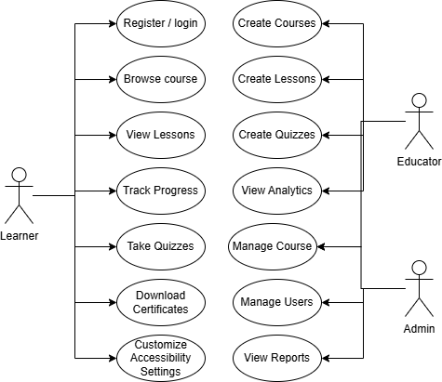
Figure 3.2: Use Case Diagram for ACESS Platform

Use Case Diagram Figure 3.2 visually maps the interactions between the primary actors (Student, Educator, Admin) and the system’s functional boundaries, which are explicitly detailed in the subsequent tables.

Student Functions

Table 3.1: Functional Requirements: Student Module

Req ID | Description | Actor | Inputs | Outputs
FR-STU-01 | Registration and secure login. | Student | Email, Password | Authenticated JWT Session.
FR-STU-02 | Accessibility profile selection. | Student | Theme, Font, TTS  preferences | Updated user\_profiles. accessibility\  _prefs record; UI  dynamically alters.
FR-STU-03 | Course discovery and enrollment. | Student | course_id  selection | INSERT into enrollments; unlocks course content.
FR-STU-04 | Lesson viewing with Focus Mode. | Student | Navigation to ‘/lesson/[id]‘ | Renders sanitized HTML; hides global navigation elements.
FR-STU-05 | Interactive video questions. | Student | Video timestamp trigger | Pauses video, renders embedded question overlay.
FR-STU-06 | Quiz participation. | Student | Selected quiz_ options | Evaluates score; INSERTs into quiz_attempts.
FR-STU-07 | Automated Progress tracking. | Student | Dwell time on lesson route | UPDATEs time_spent in lesson_progress.
FR-STU-08 | Achievement earning. | Student | 100% module completion | Unlocks gamified badge in UI.
FR-STU-09 | Certificate generation/viewing. | Student | 100% course completion | Generates verifiable PDF; displays download link.

Educator Functions

Table 3.2: Functional Requirements: Educator Module

Req ID | Description | Actor | Inputs | Outputs
FR-EDU-01 | Course creation and editing. | Educator | Title, metadata,  difficulty_ level | INSERT/UPDATE  courses table.
FR-EDU-02 | Lesson creation via Tiptap. | Educator | Rich-text content | Sanitized HTML string saved to lessons. content_html.
FR-EDU-03 | Quiz and Activity creation. | Educator | Question text, Correct option flag | Populates quiz_questions and quiz_options linked via FK.
FR-EDU-04 | Asset management. | Educator | MP4/Image files | Uploads to Supabase Storage; returns secure URL.
FR-EDU-05 | Student monitoring & Analytics. | Educator | Selection of  course_id | Renders Recharts graphs aggregating lesson_progress data.
FR-EDU-06 | Achievement configuration. | Educator | Threshold values | Maps achievements to specific course_milestones.

Admin Functions

Table 3.3: Functional Requirements: Admin Module

Req ID | Description | Actor | Inputs | Outputs
FR-ADM-01 | User role management. | Admin | Target user_id, new role string | UPDATEs users.role allowing bypass of middleware RBAC.
FR-ADM-02 | Course moderation pipeline. | Admin | Review action (Approve/Reject | UPDATEs  )courses.status from pending_review to published.
FR-ADM-03 | Accessibility preset management. | Admin | Global CSS variable thresholds | Updates system default fallbacks for Dyslexia/ADHD themes.
FR-ADM-04 | System course creation. | Admin | Course metadata | Flags course as system_ course=true, bypassing educator limits.
FR-ADM-05 | Global Analytics monitoring. | Admin | Date range filters | Aggregates platform-wide engagement metrics.

Non-Functional Requirement

Non-functional requirements (NFRs) specify the critical quality attributes and systemic constraints that govern the operation of the ACESS platform.

Performance

- Page Response Time: Next.js Client-side route transitions must execute within 300ms to prevent cognitive disruption and maintain user focus.
- Course Loading: Server-side data fetching for initial course loads must resolve within 800ms, leveraging edge caching where applicable.
- Video Loading: Embedded instructional videos must commence playback within 2 seconds utilizing adaptive bitrate streaming via Supabase Storage CDNs.
- Concurrent Users: The PostgreSQL database, utilizing connection pooling (PgBouncer), must support a minimum of 500 concurrent intensive operations (e.g., simultaneous quiz submissions) without degrading frontend TTFB (Time to First Byte).

Security

- Authentication: All user sessions must be cryptographically secured using JSON Web Tokens (JWT) managed by Supabase Auth, with a mandatory 15-minute inactivity timeout.
- Authorization (RBAC): The application middleware must definitively intercept and route requests based on the role claim within the JWT, achieving zero-trust client routing.

- Database Protection: Strict Row-Level Security (RLS) must be enabled on 100% of tables containing Personally Identifiable Information (PII) or cognitive telemetry, ensuring isolation at the storage layer.
- Input Validation: All API endpoints must utilize Zod schema validation to sanitize incoming payloads, preventing SQL injection and Cross-Site Scripting (XSS).

Accessibility

- WCAG Compliance: The platform must strictly adhere to WCAG 2.2 Level AA standards [W3C Web Accessibility Initiative, 2023]. Minimum contrast ratios must exceed 4.5:1 for standard text.
- Dyslexia Support: The system must natively provide the Atkinson Hyperlegible typeface [Atkinson, 2021] and allow users to dynamically increase line-spacing to 1.75em.
- ADHD and Autism Support: The implementation of a global reduced-motion attribute must programmatically disable all CSS and JavaScript animations [Framer, 2024]. Focus Mode must isolate content to a 65-character maximum width to reduce saccadic fatigue.
- Screen Reader Compatibility: All custom UI components must natively handle WAI-ARIA states such as aria-expanded and aria-hidden, and support complete keyboard navigation.

Usability

- Consistent Navigation: The primary navigational architecture must remain structurally identical across all modules to ensure predictability for Autistic learners.
- Error Prevention: Destructive actions (e.g., an Educator deleting a course) must require a confirmed multi-step verification modal to prevent accidental data loss.

Reliability

- Data Integrity: The database schema must strictly enforce foreign key constraints with cascade deletes where appropriate to prevent orphaned records, such as a lesson progress record existing without a valid enrollment.
- Backup Strategy: The Supabase infrastructure must be configured to execute automated, daily Point-in-Time Recovery (PITR) backups of the entire PostgreSQL volume.

Maintainability and Scalability

- Modular Architecture: The codebase must adhere to strict separation of concerns, decoupling the data-fetching logic (Server Components) from the interactive accessibility logic (Client Components).
- Database Normalization: The schema must adhere to the Third Normal Form (3NF) to eliminate data redundancy, ensuring the database scales efficiently as course and user volume increases.

Others Requirement

The software and hardware tools selected for the ACESS platform, as listed in Chapter 2, Section 2.4, are justified by the following architectural considerations:

- Next.js 16 and React [Vercel Inc., 2023a]: Server-side rendering and React Server Components reduce initial JavaScript payload, critical for rapid page loads that prevent cognitive drop-off for ADHD learners. The App Router provides middleware-based route protection that enforces role-based access at the edge.
- Supabase with PostgreSQL [Supabase, 2023]: Row-Level Security provides data isolation [Supabase, 2024] at the database level rather than relying solely on

application-layer guards, ensuring that cognitive telemetry and assessment data remain cryptographically isolated per user.
- Tailwind CSS v4 [Tailwind Labs, 2023]: Just-in-Time compilation enables dynamic CSS variable injection, allowing instantaneous theme and typography switching without JavaScript re-evaluation, which is essential for real-time accessibility adjustments.
- TypeScript [Microsoft, 2023]: Static typing across the full stack reduces runtime errors in critical paths such as quiz scoring and accessibility profile application, where a type mismatch could result in incorrect interface rendering.
- Vercel [Vercel Inc., 2023b]: Serverless edge deployment provides global low-latency access to the platform, which is particularly important for learners whose cognitive focus may be disrupted by slow page transitions.

System Architecture

The ACESS platform employs a modern, decoupled client-server architecture, leveraging edge computing paradigms to maximize performance and security.

Context Diagram

The Context Diagram establishes the highest-level view of the system, illustrating the boundaries of the ACESS platform and its interactions with external entities.

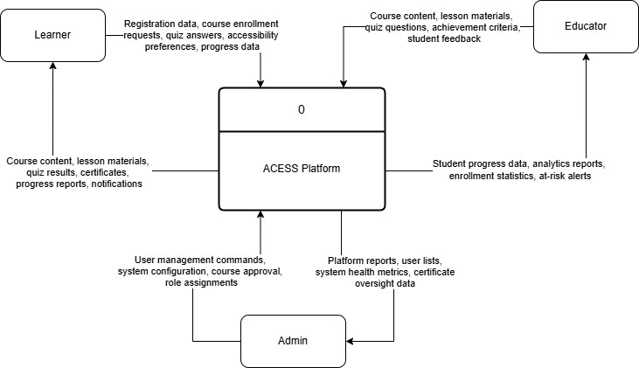
Figure 3.3: Context Diagram

As depicted in Figure 3.3, the ACESS system acts as the central processing hub. The primary external entities are the Learner (who consumes content and provides telemetry), the Educator (who authors content and configures assessments), and the Administrator (who governs system integrity). The system also interfaces with external secure email providers (for authentication/password resets) and potentially external text-to-speech APIs, though native browser synthesis is prioritized.

System Architecture Diagram

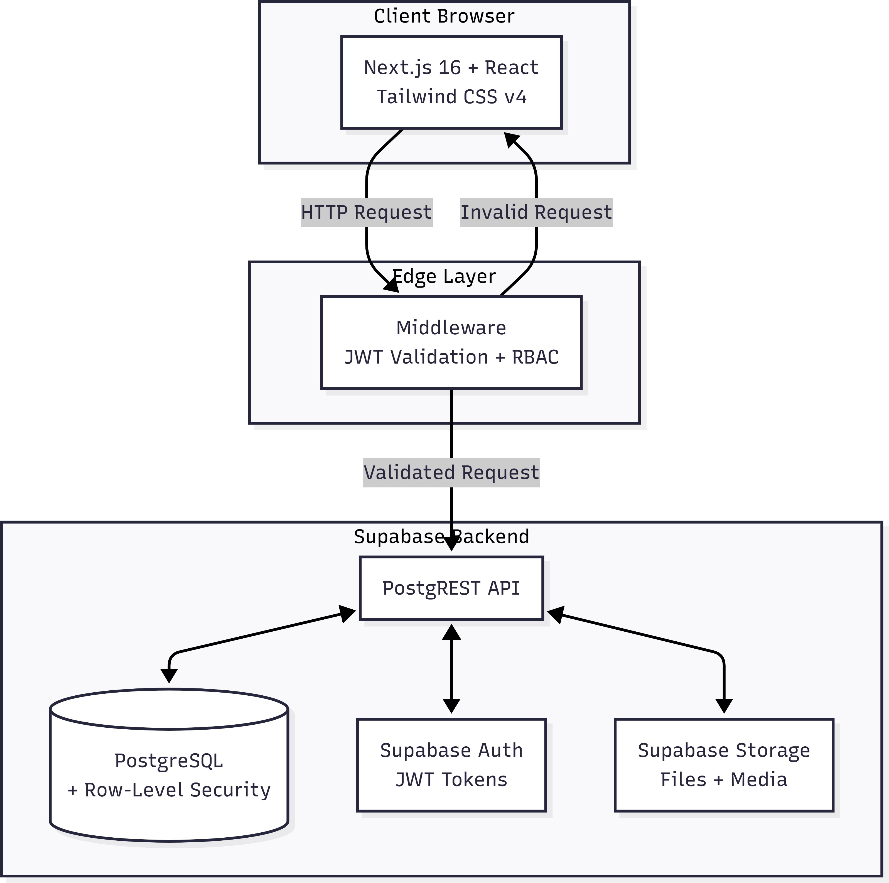
Figure 3.4: System Architecture Diagram

Figure 3.4 details the three-tier decoupled architecture:

- Frontend Architecture (Next.js 16 and React): The presentation layer is built on the Next.js App Router. It utilizes React Server Components to execute data fetching securely on the server, drastically reducing the JavaScript payload delivered to the client. This is crucial for rapid page loads, preventing cognitive drop-off for ADHD learners. Client components are restricted to highly interactive elements, such as the rich-text editor and interactive quiz interfaces. The UI is styled utilizing Tailwind CSS v4, which enables the dynamic injection of CSS variables for accessibility toggling.
- Middleware and Authentication Layer: A Next.js Edge Middleware intercepts every incoming request. It interfaces with the authentication system to validate

JWT cookies and extract the user’s role. The middleware enforces strict Role-Based Access Control (RBAC), instantly redirecting unauthorized attempts before the page is even rendered.
- Backend and Database Architecture (Supabase): Supabase acts as the comprehensive Backend-as-a-Service. It provides a managed PostgreSQL database, handling complex relational queries. Crucially, data security is not solely reliant on the API layer. PostgreSQL Row-Level Security policies are inscribed directly into the database schema, ensuring users can only read, create, or update records they own.
- Storage Architecture: Supabase Storage buckets manage unstructured assets such as course thumbnails, PDF certificates, and embedded videos. These buckets are governed by parallel security policies, ensuring private assets remain inaccessible to unauthenticated requests.

Deployment Diagram

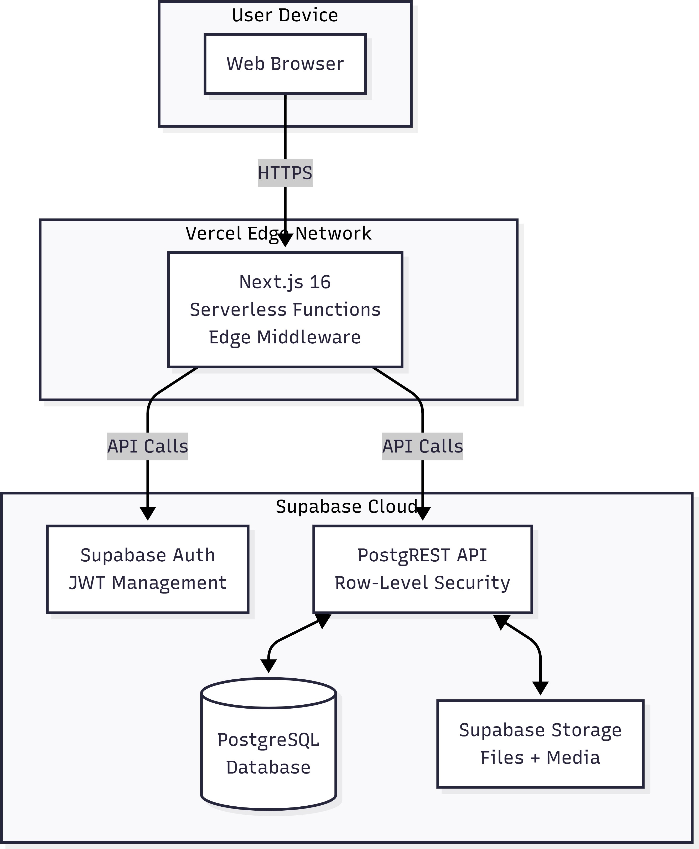
Figure 3.5: Deployment Diagram

The Deployment Diagram (Figure 3.5) illustrates the physical distribution of the system components. The Next.js frontend is deployed to a serverless edge network (e.g., Vercel or AWS Amplify), ensuring high availability and low latency globally. The Supabase backend operates on dedicated cloud infrastructure, exposing a secure REST/GraphQL API via PostgREST, which the Next.js server components consume securely.

Module Design

The system is logically partitioned into discrete, highly cohesive modules to facilitate maintainability.

- Student Module: Encapsulates all logic related to course discovery, enrollment, lesson consumption, and quiz execution.
- Educator Module: Manages the creation pipeline. Handles the rich-text editor state, quiz generation, and the uploading of media assets to storage.
- Admin Module: Provides a high-level oversight interface for user management, role reassignment, and global accessibility preset configurations.
- Accessibility Module: A globally available React Context Provider that subscribes to the user’s preferences and dynamically manipulates the DOM root attributes for theme and motion settings.
- Interactive Activity Module: Governs the execution of varied assessment types, including standard multiple-choice quizzes and embedded video questions, immediately evaluating responses in the backend.
- Analytics Module: Aggregates data from lesson progress and quiz attempts to render visualizations, providing educators with actionable intelligence on cohort performance.

Summary

This chapter analyzed the engineering specifications required to build the ACESS platform. It began with a detailed problem analysis of existing educational systems, followed by a comprehensive requirements analysis covering data, functional, non-functional, and other requirements. The system architecture was presented through Context, Architecture, and Deployment diagrams, and the modular decomposition of the system was described. The subsequent chapter will translate these requirements into concrete database schemas and interface designs.

CHAPTER 4: SYSTEM DESIGN

Introduction

This chapter translates the conceptual requirements established in the previous phase into concrete, highly granular engineering designs. It is structured according to the High-Level Design and Detailed Design phases. High-Level Design encompasses behavioral and interaction diagrams, user interface design specifications, and the conceptual database model. Detailed Design covers the software component architecture, physical database implementation, and systemic implementation details of the ACESS platform.

High-Level Design

Behavioral Design (Activity Diagrams)

Activity diagrams model the workflow of the system, illustrating the procedural logic executed by the different actors.

Student Activity Diagram

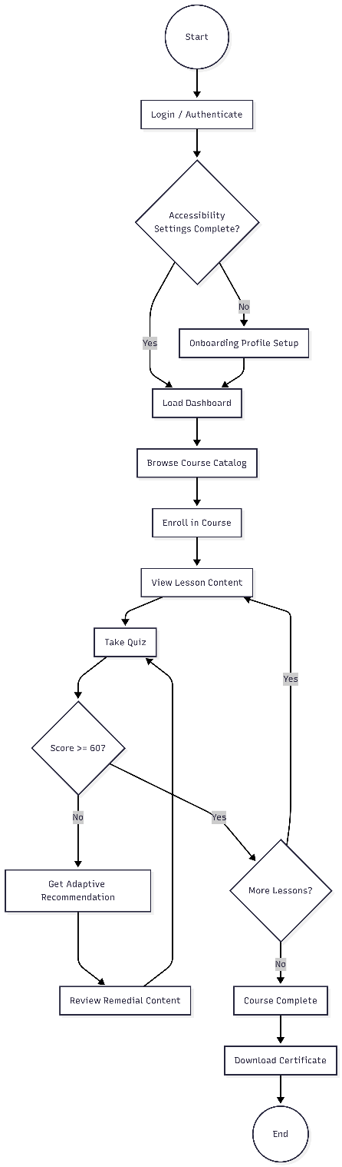

Figure 4.1: Student Activity Diagram

As shown in Figure 4.1, the Student workflow is highly structured. Upon authentication, the system evaluates the user accessibility settings. If incomplete, the user is routed to an onboarding profile setup. Once the dashboard loads, the core loop involves browsing the catalog, initializing an enrollment, and sequentially consuming lessons. The critical branching logic occurs post-assessment: if a quiz score is below the predefined threshold, the system diverges from the linear path, querying the recommendations table and forcing the student to review foundational material before progressing.

Educator Activity Diagram

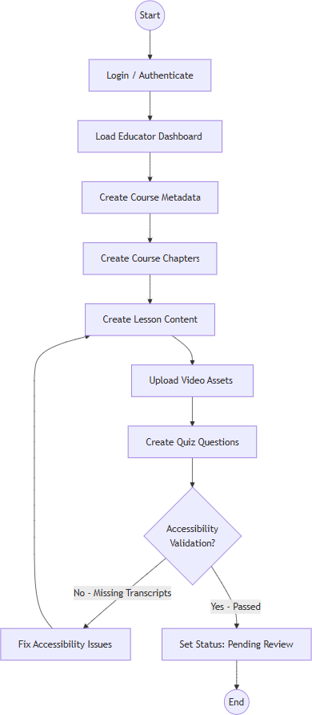
Figure 4.2: Educator Activity Diagram

As shown in Figure 4.1, the Student workflow is highly structured. Upon authentication, the system evaluates the user accessibility settings. If incomplete, the user is routed to an onboarding profile setup. Once the dashboard loads, the core loop involves browsing the catalog, initializing an enrollment, and sequentially consuming lessons. The critical branching logic occurs post-assessment: if a quiz score is below the predefined threshold, the system diverges from the linear path, querying the recommendations table and forcing the student to review foundational material before progressing.

Administrator Activity Diagram

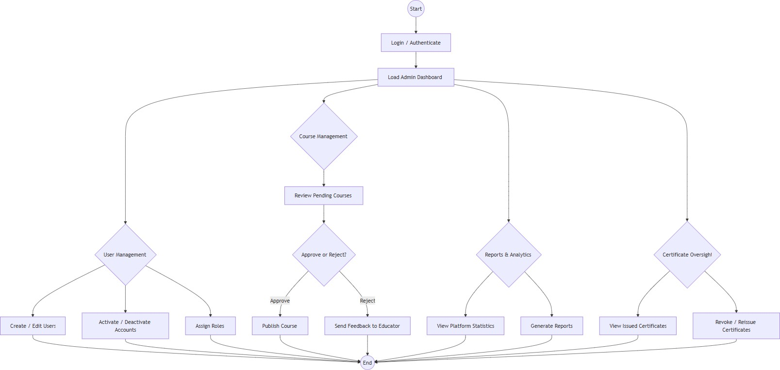
Figure 4.3: Administrator Activity Diagram

The Administrator workflow (Figure 4.3) is primarily reactive. The admin monitors the moderation queue. When a course enters pending review, the admin evaluates it against overarching accessibility guidelines. If rejected, a notification payload is dispatched to the educator. If approved, the course is published. Furthermore, the admin workflow includes auditing user logs and modifying global system variables.

Interaction Design (Sequence Diagrams)

Sequence diagrams detail how objects interact over time to execute specific Use Cases, mapping the exact API calls between the Next.js client, the Edge Middleware, and the Supabase backend.

Sequence: Course Enrollment

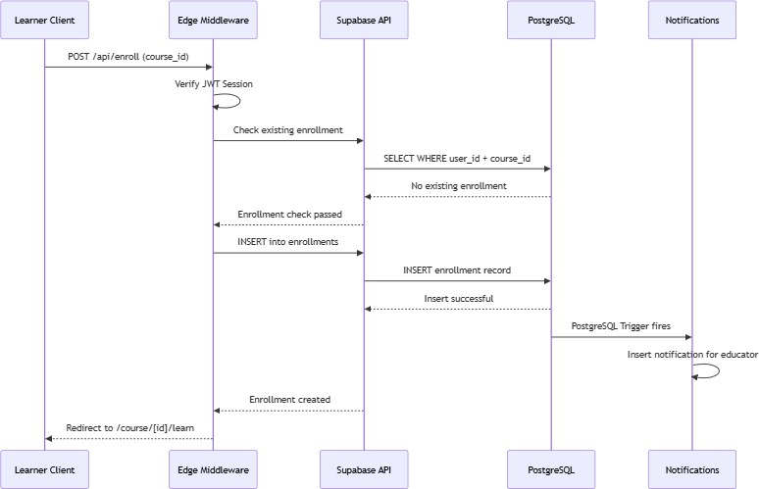

Figure 4.4: Course Enrollment Sequence Diagram

Figure 4.4 illustrates the enrollment transaction. 1. The Learner Client sends a POST /api/enroll request containing the course id. 2. The Edge Middleware intercepts, verifying the JWT session. 3. The API queries Supabase to check for existing enrollments (preventing duplicates). 4. An ‘INSERT‘ operation is executed on the ‘enrollments‘ table. 5. A PostgreSQL Trigger fires, executing a webhook that inserts a record into the ‘notifications‘ table, alerting the educator. 6. The client is redirected to the ‘/course/[id]/learn‘ route.

Sequence: Lesson Learning & Telemetry

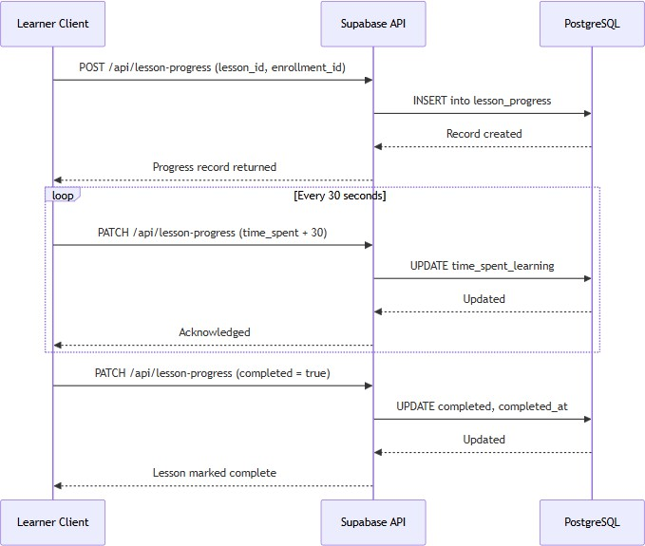

Figure 4.5: Lesson Learning Sequence Diagram

Figure 4.5 maps the continuous telemetry tracking. When a learner mounts a lesson component, an INSERT establishes a lesson progress record. As the user dwells on the page, a client-side setInterval function fires every 30 seconds, dispatching an asynchronous PATCH request to update the time spent learning integer in the database. This guarantees highly accurate engagement metrics even if the user closes the browser abruptly.

Sequence: Quiz Attempt & Adaptive Recommendation

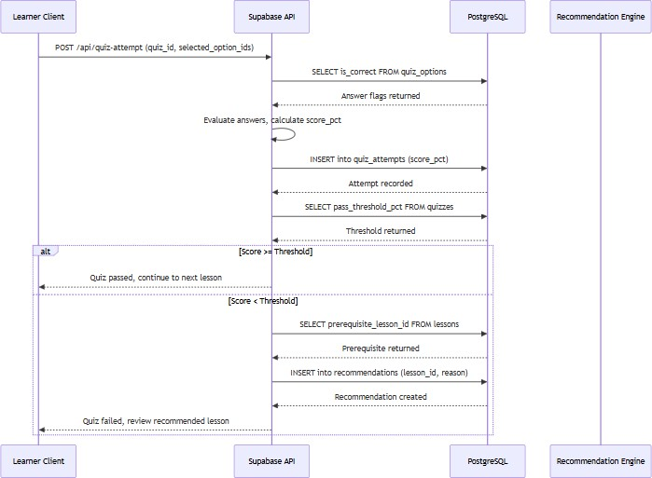

Figure 4.6: Quiz Attempt Sequence Diagram

Figure 4.6 details the most complex systemic interaction: the adaptive engine. 1. The Learner submits a JSON payload of selected option id values. 2. The backend securely evaluates these against the is correct flags in quiz options, ensuring the client never possesses the answer key. 3. The aggregate score pct is inserted into quiz attempts. 4. The server evaluates the score against quizzes.pass threshold pct. 5. If failed, the backend queries lessons.prerequisite lesson id. 6. An INSERT is executed on the recommendations table, flagging the prerequisite for mandatory review.

Sequence: Course Creation & Media Upload

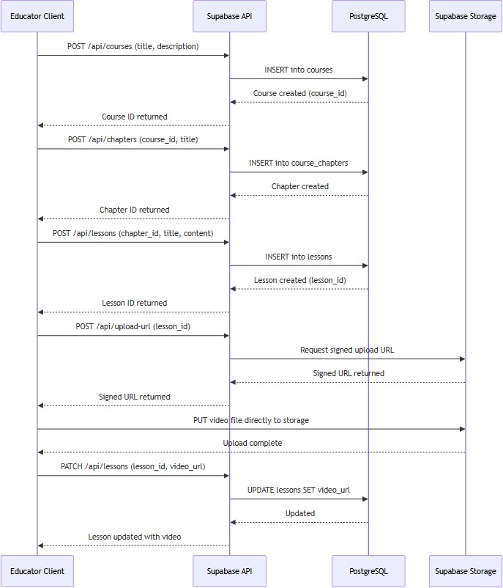

Figure 4.7: Course Creation Sequence Diagram

Figure 4.7 shows the Educator authoring pipeline. When an educator uploads a video, the Next.js API requests a signed upload URL from Supabase Storage. The client then uploads the binary blob directly to the course-assets bucket, bypassing the Next.js server to prevent memory bottlenecks. The resulting public URL is then stored within the lessons.video url attribute.

User Interface Design

The interface architecture of ACESS is organized into three role-specific shells, each with distinct navigation structures, input mechanisms, and output presentations.
Navigation Design The navigation architecture follows a role-based shell pattern enforced by Next.js middleware:

      - Public Navigation: Unauthenticated users access the landing page, login, signup, and password reset routes. The landing page features a hero section, feature highlights, system capabilities showcase, and a role-based demo modal.
      - Learner Navigation: The learner shell (LearnerShell) contains a persistent collapsible sidebar with links to Dashboard, Courses, Progress, Certificates, Achievements, and Favorites. A top bar displays the accessibility settings toggle, notification bell with unread badge count, language switcher, and user profile menu. The sidebar auto-hides in Focus Mode when navigating to lesson routes.
      - Educator Navigation: The educator shell (EducatorShell) provides a sidebar with Dashboard, My Courses, All Courses, Students, Analytics, and Certificates. A course workspace sub-navigation includes tabs for Builder, Lessons, Quiz Settings, Assets, and Preview.
      - Administrator Navigation: The admin shell (AdminShell) includes links to Dashboard, Users, Courses, Certificates, Analytics, Reports, Instructor Applications, and Contact Messages, with CRUD sub-navigation for course and user management.

Input Design The system implements structured input forms with client-side and server-side validation. Key input interfaces include:

      - User Registration and Profile: Registration form collects email, password, and role selection (learner/educator) with Zod validation for email format and password strength (minimum 8 characters, uppercase, number). Profile editing allows avatar upload via Supabase Storage with MIME type validation.
      - Course Creation (Educator): Course metadata form includes title (required, max 200 characters), slug (auto-generated with uniqueness validation), description, difficulty level (select: beginner/intermediate/advanced), category, and thumbnail upload. Validation prevents duplicate slugs at the database level.
      - Lesson Editor (Tiptap): Rich-text editor with constrained toolbar (headings, bold, italic, lists, links, code blocks, tables). Accessibility validation enforces heading hierarchy (no skipped levels), alt-text requirements on images, and caption requirements on video embeds. Content is sanitized server-side before persisting to lessons.content html.
      - Quiz Builder (Educator): Question creation interface supports multiple-choice and scenario types. Each question requires a minimum of two options with exactly one marked correct via radio button. Validation prevents publishing quizzes with unanswered questions or missing correct-option flags.
      - Accessibility Settings (Learner): A modal interface with toggle switches, dropdown selects, and slider controls for font size, line spacing, theme (light/dark/soft/high contrast), background tint picker, TTS enablement, captions, reduced motion, simplified UI, and keyboard navigation. All changes apply instantly via React Context without page reload.
      - Interactive Activity Builder (Educator): Form-based interfaces for creating flashcards (front/back text or image), drag-and-drop activities (categories and draggable items), fill-in-the-blanks (sentence with missing word), memory games (card pairs), and timelines (ordered events). Each activity type has dedicated validation rules.

Output Design The system produces the following outputs:

      - Progress Analytics (Recharts): Educator dashboards render bar charts, line charts, and pie charts using Recharts components, visualizing enrollment rates, lesson completion percentages, average time spent per lesson, and quiz score distributions. Data is aggregated server-side via PostgreSQL queries and delivered as typed arrays to chart components.
      - PDF Certificates (jsPDF): Upon course completion, the system generates a landscape PDF certificate containing the learner’s full name, course title, completion date, a unique alphanumeric reference code, and institutional branding. The PDF is generated server-side via generatePDFCertificate() in certificate-utils.ts and uploaded to Supabase Storage with the URL stored in the certificates table.
      - Administrator Reports: Custom report generation with configurable date ranges, user filters, and metric selection. Output is available as PDF or CSV download, generated via /api/admin/reports.
      - Badge and Achievement Notifications: Visual milestone badges are awarded and displayed on the learner dashboard and certificates page when predefined criteria (e.g., 100% module completion, perfect quiz score) are met, evaluated by the achievement-engine.ts.
      - Progress Summary: The learner dashboard displays a progress overview card showing enrolled course count, completed lessons, certificates earned, and achievements unlocked, with a call-to-action for the next recommended lesson.

Database Design & Entity Relationship

The data architecture is completely normalized. Data isolation is guaranteed via Row-Level Security (RLS) policies [Supabase, 2024].

53

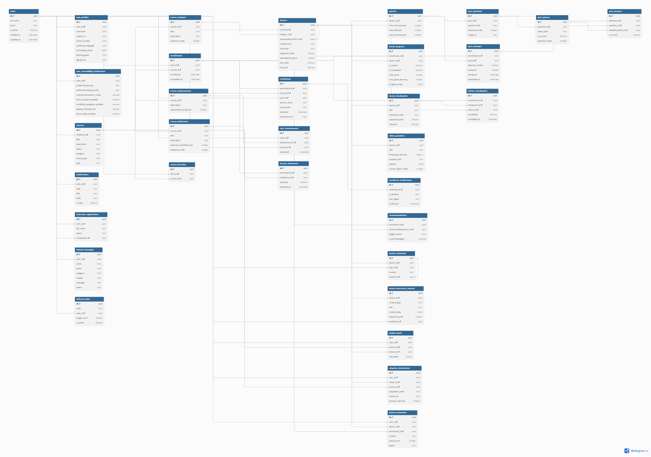
Figure 4.8: Database Entity Relationship Diagram

Figure 4.8 maps the complex relational lattice underpinning the system. The ‘users‘ table acts as the central hub, cascading outward to authorization profiles and created content.

Comprehensive Data Dictionary

The following tables constitute the exact physical schema of the ACESS PostgreSQL database.

Core Identity and Configuration

- Table: users
Table 4.1: Users Data Dictionary

Attribute | Type | Constraint | Description
id | uuid | NOT NULL | Unique identifier (UUID v4).
email | character varying | NOT NULL | User email address, used for login and notifications.
role | character varying | NOT NULL | User role: learner, educator, or admin.
is active | boolean DEFAULT true | NOT NULL | Soft-ban flag; inactive users cannot log in.
email verified at | timestamp without time zone | - | Data attribute.
last login at | timestamp without time zone | - | Timestamp of last successful login.
created at | timestamp without time zone DEFAULT now() | NOT NULL | Timestamp when the record was created.
updated at | timestamp without time zone DEFAULT now() | NOT NULL | Timestamp of the last modification.
deleted at | timestamp without time zone | - | Soft-delete timestamp; null if not deleted.
full name | text | - | User’s display name shown across the platform.
instructor application status | text | - | Status of educator application.

Table: user profiles

Table 4.2: User Profiles Data Dictionary

Attribute | Type | Constraint | Description
id | uuid DEFAULT gen random uuid() | NOT NULL | Unique identifier (UUID v4).
user id | uuid | NOT NULL | Foreign key referencing users.id.
username | text | - | Public-facing username handle.
avatar url | text | - | URL to the user’s profile image.
phone number | text | - | Data attribute.
birth date | date | - | Data attribute.
bio | text | - | Short biographical text for educator profiles.
country | text | - | Data attribute.
preferred language | text | DEFAULT ’en’::text | UI language code (en, ms).
created at | timestamp with time zone | DEFAULT now() | Timestamp when the record was created.
updated at | timestamp with time zone | DEFAULT now() | Timestamp of the last modification.
learning goals | text | - | Data attribute.
onboarded at | timestamp without time zone | - | Data attribute.
disability type | character varying | - | Disability classification for adaptive engine.
accessibility prefs | jsonb | DEFAULT ’’::jsonb | Data attribute.
notification prefs | jsonb | DEFAULT ’’::jsonb | Data attribute.
age group | text | - | Data attribute.

Table: user accessibility preferences
Table 4.3: User Accessibility Preferences Data Dictionary

Attribute | Type | Constraint | Description
id | uuid DEFAULT gen random uuid() | NOT NULL | Unique identifier (UUID v4).
user id | uuid | NOT NULL | Foreign key referencing users.id.
preferred text size | text | DEFAULT  ’medium’::text | Data attribute.
preferred reading mode | text | DEFAULT  ’standard’::text | Data attribute.
reduced stimulation mode | boolean DEFAULT false | NOT NULL | Data attribute.
text to speech enabled | boolean DEFAULT false | NOT NULL | Data attribute.
simplified navigation enabled | boolean DEFAULT false | NOT NULL | Data attribute.
dyslexia friendly font | boolean DEFAULT false | NOT NULL | Switches to Atkinson Hyperlegible typeface.
focus mode enabled | boolean DEFAULT false | NOT NULL | Data attribute.
created at | timestamp with time zone DEFAULT now() | NOT NULL | Timestamp when the record was created.
updated at | timestamp with time zone DEFAULT now() | NOT NULL | Timestamp of the last modification.
tts rate | real | DEFAULT 1.0 | Data attribute.
tts voice uri | text | - | Data attribute.
custom notes | text | - | Data attribute.

Table: enrollments
Table 4.4: Enrollments Data Dictionary

Attribute | Type | Constraint | Description
id | uuid DEFAULT gen random uuid() | NOT NULL | Unique identifier (UUID v4).
user id | uuid | NOT NULL | Foreign key referencing users.id.
course id | uuid | NOT NULL | Foreign key referencing courses.id.
enrolled at | timestamp without time zone DEFAULT now() | NOT NULL | Timestamp when the enrollment was created.
completed at | timestamp without time zone | - | Timestamp when the record was completed.
status | character varying DEFAULT ’active’::character varying | NOT NULL | Record status (e.g., active, completed, dropped).

Table: accessibility templates
Table 4.5: Accessibility Templates Data Dictionary

Attribute | Type | Constraint | Description
id | uuid DEFAULT gen random uuid() | NOT NULL | Unique identifier (UUID v4).
name | text | NOT NULL | Display name of the record.
description | text | - | Free-text description or summary.
target disability | text | NOT NULL | Data attribute.
content structure | jsonb | NOT NULL | Data attribute.
created at | timestamp with time zone DEFAULT now() | NOT NULL | Timestamp when the record was created.

Table: adaptive interactions
Table 4.6: Adaptive Interactions Data Dictionary

Attribute | Type | Constraint | Description
id | uuid DEFAULT gen random uuid() | NOT NULL | Unique identifier (UUID v4).
user id | uuid | NOT NULL | Foreign key referencing users.id.
lesson id | uuid | - | Foreign key referencing lessons.id.
course id | uuid | - | Foreign key referencing courses.id.
adaptation used | text | NOT NULL | Data attribute.
session id | text | - | Data attribute.
duration seconds | integer | - | Duration in seconds.
created at | timestamp with time zone DEFAULT now() | NOT NULL | Timestamp when the record was created.

Table: instructor applications
Table 4.7: Instructor Applications Data Dictionary

Attribute | Type | Constraint | Description
id | uuid DEFAULT gen random uuid() | NOT NULL | Unique identifier (UUID v4).
user id | uuid | - | Foreign key referencing users.id.
full name | text | NOT NULL | User’s display name shown across the platform.
email | text | NOT NULL | User email address, used for login and notifications.
experience | text | - | Data attribute.
reason | text | - | Data attribute.
portfolio links | text | - | Data attribute.
referral code | text | - | Unique referral token string.
status | text DEFAULT ’pending’::text | NOT NULL | Record status (e.g., active, completed, dropped).
admin notes | text | - | Data attribute.
reviewed by | uuid | - | Data attribute.
reviewed at | timestamp with time zone | - | Timestamp of the review decision.
created at | timestamp with time zone | DEFAULT now() | Timestamp when the record was created.
updated at | timestamp with time zone | DEFAULT now() | Timestamp of the last modification.

Table: password reset tokens
Table 4.8: Password Reset Tokens Data Dictionary

Attribute | Type | Constraint | Description
id | uuid DEFAULT gen random uuid() | NOT NULL | Unique identifier (UUID v4).
user id | uuid | NOT NULL | Foreign key referencing users.id.
email | text | NOT NULL | User email address, used for login and notifications.
token | text | NOT NULL | Data attribute.
expires at | timestamp with time zone | NOT NULL | Token expiration timestamp.
used | boolean DEFAULT false | NOT NULL | Data attribute.
created at | timestamp with time zone DEFAULT now() | NOT NULL | Timestamp when the record was created.

Table: referral codes

Table 4.9: Referral Codes Data Dictionary

Attribute | Type | Constraint | Description
id | uuid DEFAULT gen random uuid() | NOT NULL | Unique identifier (UUID v4).
code | text | NOT NULL | Data attribute.
user id | uuid | - | Foreign key referencing users.id.
usage count | integer | DEFAULT 0 | Number of times used.
max uses | integer | DEFAULT 50 | Data attribute.
is active | boolean | DEFAULT true | Soft-ban flag; inactive users cannot log in.
created at | timestamp with time zone | DEFAULT now() | Timestamp when the record was created.

Curriculum Structure

- Table: courses

Table 4.10: Courses Data Dictionary

Attribute | Type | Constraint | Description
id | uuid DEFAULT gen random uuid() | NOT NULL | Unique identifier (UUID v4).
created by | uuid | NOT NULL | Foreign key referencing the creating user.
title | character varying | NOT NULL | Display title of the record.
slug | character varying | NOT NULL | URL-safe identifier string.
description | text | - | Free-text description or summary.
status | character varying DEFAULT ’draft’::character varying | NOT NULL | Record status (e.g., active, completed, dropped).
difficulty level | character varying | - | Data attribute.
thumbnail url | character varying | - | URL to the thumbnail image.
published at | timestamp without time zone | - | Timestamp when published.
created at | timestamp without time zone DEFAULT now() | NOT NULL | Timestamp when the record was created.
updated at | timestamp without time zone DEFAULT now() | NOT NULL | Timestamp of the last modification.
deleted at | timestamp without time zone | - | Soft-delete timestamp; null if not deleted.
category | text | - | Content category classification.
course type | text DEFAULT ’educator’::text | NOT NULL | Data attribute.
system course | boolean DEFAULT false | NOT NULL | Data attribute.
built in course | boolean DEFAULT false | NOT NULL | Data attribute.
created by role | text DEFAULT ’educator’::text | NOT NULL | Data attribute.
guided learning enabled | boolean DEFAULT false | NOT NULL | Data attribute.
official course order | integer | - | Data attribute.
managed by admin | boolean DEFAULT false | NOT NULL | Data attribute.
recommended age group | text | - | Data attribute.
learning streaks enabled | boolean DEFAULT false | NOT NULL | Data attribute.
milestone tracking enabled | boolean DEFAULT false | NOT NULL | Data attribute.
accessibility mode enabled | boolean DEFAULT false | NOT NULL | Data attribute.
course layout type | text DEFAULT ’standard’::text | NOT NULL | Data attribute.
chapter organization enabled | boolean DEFAULT false | NOT NULL | Data attribute.
certificate enabled | boolean | DEFAULT false | Data attribute.
certificate settings | jsonb | DEFAULT ’’::jsonb | Data attribute.
certification locked | boolean | DEFAULT false | Data attribute.
supports tts | boolean | DEFAULT false | Data attribute.
supports transcripts | boolean | DEFAULT false | Data attribute.
supports focus mode | boolean | DEFAULT false | Data attribute.
supports chunked learning | boolean | DEFAULT false | Data attribute.
tags | text[] | DEFAULT ’’::text[] | JSONB array of tag strings.
accessibility categories | text[] | DEFAULT ’’::text[] | Data attribute.
primary disability focus | text | - | Data attribute.
secondary disability focuses | text[] | DEFAULT ’’::text[] | Data attribute.
target reading age | integer | DEFAULT 13 | Data attribute.
educator custom guide | text | - | Data attribute.

Table: lessons
Table 4.11: Lessons Data Dictionary

Attribute | Type | Constraint | Description
id | uuid DEFAULT gen random uuid() | NOT NULL | Unique identifier (UUID v4).
course id | uuid | NOT NULL | Foreign key referencing courses.id.
title | character varying | NOT NULL | Display title of the record.
content html | text | - | Data attribute.
video url | character varying | - | Data attribute.
transcript | text | - | Data attribute.
sequence order | integer | NOT NULL | Data attribute.
status | character varying DEFAULT ’draft’::character varying | NOT NULL | Record status (e.g., active, completed, dropped).
created at | timestamp without time zone DEFAULT now() | NOT NULL | Timestamp when the record was created.
updated at | timestamp without time zone DEFAULT now() | NOT NULL | Timestamp of the last modification.
estimated duration | integer | - | Data attribute.
prerequisite lesson id | uuid | - | Data attribute.
simplified summary | text | - | Data attribute.
accessibility notes | text | - | Accessibility improvement notes.
focus mode enabled | boolean DEFAULT false | NOT NULL | Data attribute.
chunked content enabled | boolean DEFAULT false | NOT NULL | Data attribute.
lesson type | text DEFAULT ’standard’::text | NOT NULL | Data attribute.
chapter id | uuid | - | Foreign key referencing course chapters.id.
chapter title | text | - | Data attribute.
learning objectives | text | - | Data attribute.
is template | boolean DEFAULT false | NOT NULL | Data attribute.
template id | uuid | - | Data attribute.
scheduled release at | timestamp with time zone | - | Data attribute.
visibility status | text DEFAULT ’visible’::text | NOT NULL | Data attribute.
checkpoints enabled | boolean DEFAULT false | NOT NULL | Data attribute.
adaptive learning enabled | boolean DEFAULT false | NOT NULL | Data attribute.
has video | boolean | DEFAULT true | Data attribute.
has pdf | boolean | DEFAULT true | Data attribute.
has quiz | boolean | DEFAULT true | Data attribute.
has transcript | boolean | DEFAULT true | Data attribute.
has summary activity | boolean | DEFAULT false | Data attribute.
summary source | text | DEFAULT  ’entire lesson’::text | Data attribute.
summary word target | integer | DEFAULT 100 | Data attribute.
summary key points | jsonb | DEFAULT  ’[]’::jsonb | Data attribute.
summary reflection questions | jsonb | DEFAULT  ’[]’::jsonb | Data attribute.
summary ai feedback enabled | boolean | DEFAULT false | Data attribute.
lesson layout | text | DEFAULT  ’standard’::text | Data attribute.
interactive activity type | text | - | Data attribute.
accessibility overrides | jsonb | DEFAULT ’’::jsonb | Data attribute.
accessibility score | integer | DEFAULT 100 | Accessibility compliance score.
allow discussions | boolean | DEFAULT false | Data attribute.
allow download | boolean | DEFAULT false | Data attribute.

Table: quizzes
Table 4.12: Quizzes Data Dictionary

Attribute | Type | Constraint | Description
id | uuid DEFAULT gen random uuid() | NOT NULL | Unique identifier (UUID v4).
lesson id | uuid | NOT NULL | Foreign key referencing lessons.id.
title | character varying | NOT NULL | Display title of the record.
time limit seconds | integer DEFAULT 0 | NOT NULL | Data attribute.
max attempts | integer DEFAULT 0 | NOT NULL | Maximum number of allowed attempts.
pass threshold pct | integer DEFAULT 60 | NOT NULL | Minimum percentage required to pass.
created at | timestamp without time zone DEFAULT now() | NOT NULL | Timestamp when the record was created.
updated at | timestamp without time zone DEFAULT now() | NOT NULL | Timestamp of the last modification.

Table: quiz questions
Table 4.13: Quiz Questions Data Dictionary

Attribute | Type | Constraint | Description
id | uuid DEFAULT gen random uuid() | NOT NULL | Unique identifier (UUID v4).
quiz id | uuid | NOT NULL | Foreign key referencing quizzes.id.
question text | text | NOT NULL | Display text of the question.
question type | character varying | NOT NULL | Question format  (multiple-choice, etc.).
sequence order | integer | NOT NULL | Data attribute.
created at | timestamp without time zone DEFAULT now() | NOT NULL | Timestamp when the record was created.
image url | text | - | Data attribute.

Table: quiz options
Table 4.14: Quiz Options Data Dictionary

Attribute | Type | Constraint | Description
id | uuid DEFAULT gen random uuid() | NOT NULL | Unique identifier (UUID v4).
question id | uuid | NOT NULL | Foreign key referencing quiz questions.id.
option text | text | NOT NULL | Display text of the quiz option.
is correct | boolean DEFAULT false | NOT NULL | Whether this is the correct answer.
sequence order | integer | NOT NULL | Data attribute.
image url | text | - | Data attribute.

Table: course chapters
Table 4.15: Course Chapters Data Dictionary

Attribute | Type | Constraint | Description
id | uuid DEFAULT gen random uuid() | NOT NULL | Unique identifier (UUID v4).
course id | uuid | NOT NULL | Foreign key referencing courses.id.
title | text | NOT NULL | Display title of the record.
description | text | - | Free-text description or summary.
sequence order | integer DEFAULT 0 | NOT NULL | Data attribute.
created at | timestamp with time zone DEFAULT now() | NOT NULL | Timestamp when the record was created.

Table: course milestones
Table 4.16: Course Milestones Data Dictionary

Attribute | Type | Constraint | Description
id | uuid DEFAULT gen random uuid() | NOT NULL | Unique identifier (UUID v4).
course id | uuid | NOT NULL | Foreign key referencing courses.id.
title | text | NOT NULL | Display title of the record.
description | text | - | Free-text description or summary.
required completion pct | integer DEFAULT 100 | NOT NULL | Data attribute.
icon | text | - | Data attribute.
sequence order | integer DEFAULT 0 | NOT NULL | Data attribute.
created at | timestamp with time zone DEFAULT now() | NOT NULL | Timestamp when the record was created.

Table: course achievements

Table 4.17: Course Achievements Data Dictionary

Attribute | Type | Constraint | Description
id | uuid DEFAULT gen random uuid() | NOT NULL | Unique identifier (UUID v4).
course id | uuid | NOT NULL | Foreign key referencing courses.id.
name | character varying | NOT NULL | Display name of the record.
description | text | NOT NULL | Free-text description or summary.
icon url | character varying | - | Data attribute.
requirement type | character varying | NOT NULL | Data attribute.
requirement threshold | integer DEFAULT 1 | NOT NULL | Data attribute.
created at | timestamp with time zone DEFAULT now() | NOT NULL | Timestamp when the record was created.
updated at | timestamp with time zone DEFAULT now() | NOT NULL | Timestamp of the last modification.

Table: course accessibility categories
Table 4.18: Course Accessibility Categories Data Dictionary

Attribute | Type | Constraint | Description
id | uuid DEFAULT gen random uuid() | NOT NULL | Unique identifier (UUID v4).
course id | uuid | NOT NULL | Foreign key referencing courses.id.
accessibility category | text | NOT NULL | Data attribute.
created at | timestamp with time zone DEFAULT now() | NOT NULL | Timestamp when the record was created.

Table: course favorites
Table 4.19: Course Favorites Data Dictionary

Attribute | Type | Constraint | Description
id | uuid DEFAULT gen random uuid() | NOT NULL | Unique identifier (UUID v4).
user id | uuid | NOT NULL | Foreign key referencing users.id.
course id | uuid | NOT NULL | Foreign key referencing courses.id.
created at | timestamp with time zone | DEFAULT now() | Timestamp when the record was created.

Telemetry and Assessment

- Table: quiz attempts
Table 4.20: Quiz Attempts Data Dictionary

Attribute | Type | Constraint | Description
id | uuid DEFAULT gen random uuid() | NOT NULL | Unique identifier (UUID v4).
enrollment id | uuid | NOT NULL | Foreign key referencing enrollments.id.
quiz id | uuid | NOT NULL | Foreign key referencing quizzes.id.
attempt number | integer | NOT NULL | Sequential counter for quiz attempts.
score pct | integer | - | Quiz score as a percentage (0-100).
result | character varying DEFAULT ’in progress’::character varying | NOT NULL | Data attribute.
started at | timestamp without time zone DEFAULT now() | NOT NULL | Data attribute.
submitted at | timestamp without time zone | - | Timestamp of response submission.

Table: quiz answers
Table 4.21: Quiz Answers Data Dictionary

Attribute | Type | Constraint | Description
id | uuid DEFAULT gen random uuid() | NOT NULL | Unique identifier (UUID v4).
attempt id | uuid | NOT NULL | Foreign key referencing quiz attempts.id.
question id | uuid | NOT NULL | Foreign key referencing quiz questions.id.
selected option id | uuid | - | Foreign key referencing the chosen quiz option.
is correct | boolean | - | Whether this is the correct answer.

Table: lesson progress

Table 4.22: Lesson Progress Data Dictionary

Attribute | Type | Constraint | Description
id | uuid DEFAULT gen random uuid() | NOT NULL | Unique identifier (UUID v4).
enrollment id | uuid | NOT NULL | Foreign key referencing enrollments.id.
lesson id | uuid | NOT NULL | Foreign key referencing lessons.id.
is viewed | boolean DEFAULT false | NOT NULL | Data attribute.
view count | integer DEFAULT 0 | NOT NULL | Data attribute.
first viewed at | timestamp without time zone | - | Data attribute.
last viewed at | timestamp without time zone | - | Data attribute.
checkpoint completed | boolean DEFAULT false | NOT NULL | Data attribute.
time spent learning | integer DEFAULT 0 | NOT NULL | Data attribute.
assisted learning mode | boolean DEFAULT false | NOT NULL | Data attribute.
summary completed | boolean | DEFAULT false | Data attribute.
is completed | boolean | DEFAULT false | Data attribute.
progress meta | jsonb DEFAULT ’’::jsonb | NOT NULL | Data attribute.

Table: lesson checkpoints
Table 4.23: Lesson Checkpoints Data Dictionary

Attribute | Type | Constraint | Description
id | uuid DEFAULT gen random uuid() | NOT NULL | Unique identifier (UUID v4).
lesson id | uuid | NOT NULL | Foreign key referencing lessons.id.
title | text | NOT NULL | Display title of the record.
description | text | - | Free-text description or summary.
checkpoint type | text DEFAULT ’reflection’::text | NOT NULL | Data attribute.
sequence order | integer DEFAULT 0 | NOT NULL | Data attribute.
required | boolean DEFAULT false | NOT NULL | Data attribute.
created at | timestamp with time zone DEFAULT now() | NOT NULL | Timestamp when the record was created.

Table: learner checkpoints

Table 4.24: Learner Checkpoints Data Dictionary

Attribute | Type | Constraint | Description
id | uuid DEFAULT gen random uuid() | NOT NULL | Unique identifier (UUID v4).
enrollment id | uuid | NOT NULL | Foreign key referencing enrollments.id.
checkpoint id | uuid | - | Data attribute.
completed | boolean DEFAULT false | NOT NULL | Data attribute.
completed at | timestamp with time zone | - | Timestamp when the record was completed.
created at | timestamp with time zone DEFAULT now() | NOT NULL | Timestamp when the record was created.
response data | jsonb | - | JSONB payload of the learner’s response.
lesson id | uuid | - | Foreign key referencing lessons.id.

Table: learner milestones
Table 4.25: Learner Milestones Data Dictionary

Attribute | Type | Constraint | Description
id | uuid DEFAULT gen random uuid() | NOT NULL | Unique identifier (UUID v4).
enrollment id | uuid | NOT NULL | Foreign key referencing enrollments.id.
milestone id | uuid | NOT NULL | Foreign key referencing course milestones.id.
achieved | boolean DEFAULT false | NOT NULL | Data attribute.
achieved at | timestamp with time zone | - | Data attribute.
created at | timestamp with time zone DEFAULT now() | NOT NULL | Timestamp when the record was created.

Table: video questions
Table 4.26: Video Questions Data Dictionary

Attribute | Type | Constraint | Description
id | uuid DEFAULT gen random uuid() | NOT NULL | Unique identifier (UUID v4).
lesson id | uuid | NOT NULL | Foreign key referencing lessons.id.
title | text | NOT NULL | Display title of the record.
timestamp seconds | numeric | NOT NULL | Data attribute.
question text | text | NOT NULL | Display text of the question.
options | jsonb DEFAULT ’[]’::jsonb | NOT NULL | JSONB array of answer options.
correct option index | integer DEFAULT 0 | NOT NULL | Data attribute.
sequence order | integer DEFAULT 0 | NOT NULL | Data attribute.
created at | timestamp with time zone DEFAULT now() | NOT NULL | Timestamp when the record was created.
updated at | timestamp with time zone DEFAULT now() | NOT NULL | Timestamp of the last modification.

Learner Progress and Checkpoints

- Table: recommendations
Table 4.27: Recommendations Data Dictionary

Attribute | Type | Constraint | Description
id | uuid DEFAULT gen random uuid() | NOT NULL | Unique identifier (UUID v4).
enrollment id | uuid | NOT NULL | Foreign key referencing enrollments.id.
recommended lesson id | uuid | NOT NULL | Data attribute.
difficulty tier | character varying | NOT NULL | Data attribute.
trigger reason | text | - | Data attribute.
is acknowledged | boolean DEFAULT false | NOT NULL | Data attribute.
created at | timestamp without time zone DEFAULT now() | NOT NULL | Timestamp when the record was created.

Table: user achievements
Table 4.28: User Achievements Data Dictionary

Attribute | Type | Constraint | Description
id | uuid DEFAULT gen random uuid() | NOT NULL | Unique identifier (UUID v4).
user id | uuid | NOT NULL | Foreign key referencing users.id.
achievement id | uuid | NOT NULL | Foreign key referencing course achievements.id.
course id | uuid | NOT NULL | Foreign key referencing courses.id.
earned at | timestamp with time zone DEFAULT now() | NOT NULL | Timestamp when the achievement was earned.

Content and Media

- Table: lesson comments
Table 4.29: Lesson Comments Data Dictionary

Attribute | Type | Constraint | Description
id | uuid DEFAULT gen random uuid() | NOT NULL | Unique identifier (UUID v4).
lesson id | uuid | NOT NULL | Foreign key referencing lessons.id.
user id | uuid | NOT NULL | Foreign key referencing users.id.
content | text | NOT NULL | Rich-text HTML or JSON content body.
parent id | uuid | - | Data attribute.
created at | timestamp with time zone DEFAULT now() | NOT NULL | Timestamp when the record was created.
updated at | timestamp with time zone DEFAULT now() | NOT NULL | Timestamp of the last modification.

Table: lesson summaries

Table 4.30: Lesson Summaries Data Dictionary

Attribute | Type | Constraint | Description
id | uuid DEFAULT gen random uuid() | NOT NULL | Unique identifier (UUID v4).
user id | uuid | NOT NULL | Foreign key referencing users.id.
lesson id | uuid | NOT NULL | Foreign key referencing lessons.id.
enrollment id | uuid | NOT NULL | Foreign key referencing enrollments.id.
content | text | NOT NULL | Rich-text HTML or JSON content body.
word count | integer | DEFAULT 0 | Word count of the content.
status | text | DEFAULT  ’draft’::text | Record status (e.g., active, completed, dropped).
ai feedback | text | - | Data attribute.
educator feedback | text | - | Data attribute.
submitted at | timestamp with time zone | - | Timestamp of response submission.
created at | timestamp with time zone DEFAULT now() | NOT NULL | Timestamp when the record was created.
updated at | timestamp with time zone DEFAULT now() | NOT NULL | Timestamp of the last modification.

Table: lesson versions
Table 4.31: Lesson Versions Data Dictionary

Attribute | Type | Constraint | Description
id | uuid DEFAULT gen random uuid() | NOT NULL | Unique identifier (UUID v4).
lesson id | uuid | NOT NULL | Foreign key referencing lessons.id.
content html | text | NOT NULL | Data attribute.
version name | text | NOT NULL | Data attribute.
created at | timestamp with time zone DEFAULT now() | NOT NULL | Timestamp when the record was created.
created by | uuid | NOT NULL | Foreign key referencing the creating user.

Table: lesson interactive content

Table 4.32: Lesson Interactive Content Data Dictionary

Attribute | Type | Constraint | Description
id | uuid DEFAULT gen random uuid() | NOT NULL | Unique identifier (UUID v4).
lesson id | uuid | NOT NULL | Foreign key referencing lessons.id.
content type | text | NOT NULL | MIME type of the content.
title | text | NOT NULL | Display title of the record.
content data | jsonb DEFAULT ’’::jsonb | NOT NULL | Data attribute.
accessibility settings | jsonb | DEFAULT ’’::jsonb | Data attribute.
sequence order | integer DEFAULT 0 | NOT NULL | Data attribute.
created by | uuid | - | Foreign key referencing the creating user.
created at | timestamp with time zone DEFAULT now() | NOT NULL | Timestamp when the record was created.
updated at | timestamp with time zone DEFAULT now() | NOT NULL | Timestamp of the last modification.
is draft | boolean DEFAULT false | NOT NULL | Data attribute.

Table: lesson templates
Table 4.33: Lesson Templates Data Dictionary

Attribute | Type | Constraint | Description
id | uuid DEFAULT gen random uuid() | NOT NULL | Unique identifier (UUID v4).
created by | uuid | NOT NULL | Foreign key referencing the creating user.
title | text | NOT NULL | Display title of the record.
description | text | - | Free-text description or summary.
lesson type | text DEFAULT ’standard’::text | NOT NULL | Data attribute.
content html | text | - | Data attribute.
estimated duration | integer | - | Data attribute.
is public | boolean DEFAULT false | NOT NULL | Data attribute.
created at | timestamp with time zone DEFAULT now() | NOT NULL | Timestamp when the record was created.
updated at | timestamp with time zone DEFAULT now() | NOT NULL | Timestamp of the last modification.

Table: media assets

Table 4.34: Media Assets Data Dictionary

Attribute | Type | Constraint | Description
id | uuid DEFAULT gen random uuid() | NOT NULL | Unique identifier (UUID v4).
user id | uuid | NOT NULL | Foreign key referencing users.id.
course id | uuid | - | Foreign key referencing courses.id.
file name | character varying | NOT NULL | Data attribute.
file type | character varying | NOT NULL | MIME type of the file.
url | character varying | NOT NULL | External resource URL.
size bytes | bigint | - | Data attribute.
created at | timestamp with time zone DEFAULT now() | NOT NULL | Timestamp when the record was created.
lesson id | uuid | - | Foreign key referencing lessons.id.
title | character varying | - | Display title of the record.

Table: notifications
Table 4.35: Notifications Data Dictionary

Attribute | Type | Constraint | Description
id | uuid DEFAULT gen random uuid() | NOT NULL | Unique identifier (UUID v4).
user id | uuid | NOT NULL | Foreign key referencing users.id.
type | text | NOT NULL | Classification type of the record.
title | text | NOT NULL | Display title of the record.
body | text | - | Message body text content.
metadata | jsonb | DEFAULT ’’::jsonb | JSONB field for extensible metadata.
is read | boolean | DEFAULT false | Whether the message has been read.
created at | timestamp with time zone | DEFAULT now() | Timestamp when the record was created.

Table: contact messages

Table 4.36: Contact Messages Data Dictionary

Attribute | Type | Constraint | Description
id | uuid DEFAULT gen random uuid() | NOT NULL | Unique identifier (UUID v4).
name | text | NOT NULL | Display name of the record.
email | text | NOT NULL | User email address, used for login and notifications.
category | text | NOT NULL | Content category classification.
subject | text | NOT NULL | Message subject line.
message | text | NOT NULL | Data attribute.
status | text DEFAULT ’unread’::text | NOT NULL | Record status (e.g., active, completed, dropped).
created at | timestamp with time zone | DEFAULT now() | Timestamp when the record was created.

Table: certificates
Table 4.37: Certificates Data Dictionary

Attribute | Type | Constraint | Description
id | uuid DEFAULT gen random uuid() | NOT NULL | Unique identifier (UUID v4).
enrollment id | uuid | NOT NULL | Foreign key referencing enrollments.id.
reference code | character varying | NOT NULL | Data attribute.
pdf url | character varying | - | Data attribute.
status | character varying DEFAULT ’issued’::character varying | NOT NULL | Record status (e.g., active, completed, dropped).
issued at | timestamp without time zone DEFAULT now() | NOT NULL | Timestamp when the certificate was issued.
revoked at | timestamp without time zone | - | Data attribute.
revoke reason | text | - | Data attribute.
course id | uuid | - | Foreign key referencing courses.id.
user id | uuid | - | Foreign key referencing users.id.
learner name | text | - | Data attribute.
course title | text | - | Data attribute.
educator name | text | - | Data attribute.
institution name | text | DEFAULT ’ACESS  Platform’::text | Data attribute.
completion date | timestamp with time zone | - | Data attribute.
verification url | text | - | Data attribute.
skills earned | text[] | DEFAULT ’’::text[] | Data attribute.
course duration hours | numeric | DEFAULT 0 | Data attribute.
signed token | text | - | Data attribute.
template id | text | DEFAULT  ’default’::text | Data attribute.
metadata | jsonb | DEFAULT ’’::jsonb | JSONB field for extensible metadata.

Table: certificate templates

Table 4.38: Certificate Templates Data Dictionary

Attribute | Type | Constraint | Description
id | uuid DEFAULT gen random uuid() | NOT NULL | Unique identifier (UUID v4).
name | text | NOT NULL | Display name of the record.
description | text | - | Free-text description or summary.
layout config | jsonb | DEFAULT ’’::jsonb | Data attribute.
is active | boolean | DEFAULT true | Soft-ban flag; inactive users cannot log in.
is default | boolean | DEFAULT false | Data attribute.
created at | timestamp with time zone | DEFAULT now() | Timestamp when the record was created.
updated at | timestamp with time zone | DEFAULT now() | Timestamp of the last modification.

Table: certificate verifications
Table 4.39: Certificate Verifications Data Dictionary

Attribute | Type | Constraint | Description
id | uuid DEFAULT gen random uuid() | NOT NULL | Unique identifier (UUID v4).
certificate id | uuid | - | Foreign key referencing certificates.id.
ip address | text | - | Data attribute.
user agent | text | - | Data attribute.
verified at | timestamp with time zone | DEFAULT now() | Data attribute.

Detailed Design

Software Design

The ACESS platform follows a component-based architecture using React Server Components (RSC) and Client Components [Meta Platforms, Inc., 2023], organized by feature domain. The key software components are described below.

Provider Components (Global State)

      - AuthProvider: Wraps the application root. Initializes the Supabase client session via @supabase/ssr, exposes user object, session, signIn(), signUp(), signOut() through React Context. On mount, fetches the user’s role and profile metadata. Responsible for session refresh and 15-minute inactivity timeout detection via SessionTimeout component.
      - AccessibilityProvider: Loads user accessibility settings from Supabase on authentication. Exposes setting values and a updateSetting() method through context. On every setting change, writes to the database and applies CSS data-* attributes to the <html> element (e.g., data-theme="dyslexia", data-reduced-motion="true") which Tailwind CSS v4 [Tailwind Labs, 2023] intercepts to re-theme the entire component tree.

      - LanguageProvider: Loads the user’s preferred language from profile settings, provides a t() function that maps keys to locale strings in src/locales/en.ts and ms.ts. Supports runtime language switching without page reload.

Learner Components

      - LearnerDashboard: Server component that fetches enrolled courses, recommendations, recent progress, and achievement summary. Renders WelcomeSection, MyCoursesSection, ProgressOverview, and QuickActions client sub-components for interactive elements.
      - LessonPage: Client component receiving lessonId as prop. Fetches lesson content (content html), video URL, and quiz configuration. Renders sanitized HTML via LessonRenderer. In Focus Mode, conditionally omits sidebar and header. Tracks time spent via setInterval dispatching PATCH
/api/lesson/[id]/progress every 30 seconds.

      - QuizPage: Client component managing question navigation state, timer (derived from quizzes.time limit seconds), selected answers map, and auto-submit logic on timeout. On submission, sends selected option id[] to POST /api/quiz/[id]/attempt and displays QuizResultModal with score, pass/fail status, and answer review.
      - AccessibilitySettingsModal: Client component with toggle switches and dropdowns for all a11y settings. Each input calls updateSetting() on the AccessibilityProvider context, providing real-time preview of changes.

Educator Components

      - CourseWorkspace: Client component acting as the educator’s main working area. Manages tab state (Builder, Lessons, Quiz Settings, Assets, Preview). Contains nested routing for lesson editing within the course context.
      - LessonEditor: Client component wrapping the Tiptap editor instance [Brainhub, 2024]. Configures the editor with extensions: StarterKit, Underline, Link, Image, Table, CodeBlockLowlight, TextAlign, Highlight, TextStyle, Color, and Placeholder. Strips disallowed tags on save. Calls PUT
/api/educator/lessons/[id] to persist the sanitized HTML.

      - QuizBuilderModal: Client component for creating and editing quiz questions. Manages a dynamic list of questions each with a type selector (multiple-choice or scenario), question text input, and a dynamic list of option rows with radio-button correct-flag selection. Validates that each question has at least one correct option before allowing save.
      - InteractiveActivityBuilder: Client component with sub-builders for each activity type: FlashcardBuilder, DragDropBuilder, FillBlanksBuilder, MemoryGameBuilder, TimelineBuilder. Each sub-builder manages its specific data structure and emits a typed JSON object on save.

Administrator Components

      - UserManagement: Client component with a plain HTML table for sorting, filtering, and paginating the users list. Supports role reassignment via RoleEditModal and soft-delete toggling.
      - CourseManagement: Client component listing all courses with status filters (draft, pending review, published). Includes ThumbnailPicker for assigning stock images and AdminCourseSettingsTab for system-wide course configuration.
      - AnalyticsDashboard: Client/server hybrid component. Server-fetches aggregated platform metrics (total users, enrollments, active courses, completion rates). Renders custom CSS-based bar charts with interactive tooltips and date range filtering.

Core API Routes and Server Logic

      - POST /api/recommendations/generate: Invoked server-side after quiz attempt evaluation. Executes the recommendation-engine.ts which analyzes the learner’s enrollment context, quiz score, and prerequisite lesson chain to generate up to three recommendations (revision, standard, advanced, or cross-course). Uses Supabase service role to bypass RLS for cross-user queries.

      - PUT /api/educator/lessons/[id]: Receives sanitized HTML from Tiptap, validates with Zod, updates the lessons table, and creates a version snapshot in lesson versions for rollback support.
      - POST /api/certificates/custom: Receives a custom PDF certificate file from the educator, validates file type (PDF only) and size (max 5MB), uploads to Supabase Storage course-assets bucket, and stores the URL reference.
      - Recommendation Engine (recommendation-engine.ts): Contains generateRecommendations() function. Logic branches: revision (if recent quiz failed), standard (if unviewed lessons remain), advanced (if near course completion), cross-course (if tag-matched courses exist). Returns an ordered array of recommended lesson IDs with trigger reasons.
      - Achievement Engine (achievement-engine.ts): Contains evaluateAchievements() function called after quiz attempts and lesson completions. Checks learner’s current progress against course achievements criteria and grants new badges via user achievements insertion.
      - Adaptive Engine (adaptive-engine.ts): Applies preset-based accessibility configuration (Dyslexia, ADHD, Autism, Dyscalculia) with age-adapted sub-variants. Each preset defines a combination of settings for font family, spacing, theme, tint, reading spotlight, focus mode, chunked content, TTS, and simplified UI, applied via CSS data attributes.

Data Access Layer Data fetching is abstracted into three role-specific modules:

      - learner-api.ts: 48 exported functions covering profile management, course discovery, enrollment, lesson content retrieval, quiz attempts, progress tracking, certificate viewing, recommendation fetching, favorites, and accessibility settings CRUD.

      - educator-api.ts: 73 exported functions for course CRUD, lesson CRUD with versioning, quiz builder operations, asset upload, student progress queries, analytics aggregation, certificate management, and instructor applications.
      - admin-api.ts: 40 exported functions for user management, system course creation with chapters/milestones/templates, certificate oversight, instructor application review, contact message management, report generation, and platform health metrics.

Physical Database Design

The ACESS database is implemented on Supabase PostgreSQL 15 [Supabase, 2023]. The physical schema enforces relational integrity through foreign keys, unique constraints, and Row-Level Security policies.
Table Definitions (DDL) Core tables are created with the following representative DDL:

users table:
CREATE TABLE public.users ( id UUID PRIMARY KEY DEFAULT
gen random uuid(), email VARCHAR(255) UNIQUE NOT NULL, full name TEXT NOT NULL, role VARCHAR(20) NOT NULL DEFAULT ’learner’ CHECK (role IN
(’learner’, ’educator’, ’admin’)), is active BOOLEAN DEFAULT true, email verified at TIMESTAMPTZ, created at TIMESTAMPTZ DEFAULT NOW(), deleted at TIMESTAMPTZ );

enrollments table with unique constraint:
CREATE TABLE public.enrollments ( id UUID PRIMARY KEY DEFAULT gen random uuid(), user id UUID NOT NULL REFERENCES users(id) ON DELETE CASCADE, course id UUID NOT NULL REFERENCES courses(id) ON
DELETE CASCADE, status VARCHAR(20) DEFAULT ’active’ CHECK (status IN (’active’, ’completed’, ’dropped’)), enrolled at TIMESTAMPTZ DEFAULT NOW(), completed at TIMESTAMPTZ, UNIQUE(user id, course id) );

Indexes The following indexes are defined to optimize query performance:
CREATE INDEX idx enrollments user ON enrollments(user id); CREATE INDEX idx enrollments course ON enrollments(course id); CREATE INDEX idx lesson progress enrollment ON lesson progress(enrollment id);
CREATE INDEX idx quiz attempts enrollment ON quiz attempts(enrollment id); CREATE INDEX idx lessons course ON lessons(course id); CREATE
INDEX idx notifications user ON notifications(user id); CREATE INDEX idx courses created by ON courses(created by); CREATE INDEX idx courses status ON courses(status);

Row-Level Security Policies RLS is enabled on all tables containing user data. Representative policies include:

-- Learners can only read their own lesson progress CREATE POLICY lesson progress learner select ON lesson progress FOR SELECT USING (auth.uid() IN ( SELECT user id FROM enrollments WHERE id = enrollment id ));
-- Educators can CRUD their own courses CREATE POLICY
courses educator insert ON courses FOR INSERT WITH CHECK (auth.uid() = created by);
-- Admins can read all rows CREATE POLICY users admin select ON users FOR SELECT USING (auth.role() = ’admin’);

Database Triggers Five notification triggers are implemented as PL/pgSQL functions attached to INSERT and UPDATE events:

Systemic Implementation Details
CREATE FUNCTION notify on quiz attempt() RETURNS TRIGGER AS $$ BEGIN IF NEW.score pct < (SELECT pass threshold pct FROM quizzes WHERE id
= NEW.quiz id) THEN INSERT INTO notifications (user id, type, title, body, metadata) VALUES ( (SELECT created by FROM courses WHERE id = ( SELECT course id FROM enrollments WHERE id = NEW.enrollment id )), ’quiz failed’, ’Student Failed Quiz’, ’A learner scored below the
passing threshold.’, jsonb build object(’attempt id’, NEW.id, ’score’, NEW.score pct) ); END IF; RETURN NEW; END; $$ LANGUAGE plpgsql;
CREATE TRIGGER notify on quiz attempt trigger AFTER INSERT ON
quiz attempts FOR EACH ROW EXECUTE FUNCTION notify on quiz attempt();

Interactive Video Questions To prevent passive consumption, ACESS implements embedded video questions. This is achieved by creating a custom React hook useVideoTime() connected to an HTML5 video player reference. An array of timestamp objects is loaded from the database. When the video’s current time intersects a target timestamp, the state isVideoPaused is forced to true, and a z-index overlay modal is mounted containing a specific quiz question. The video cannot be resumed until the user interacts with the prompt.

Database Trigger Architecture (Notifications) To maintain a decoupled architecture and prevent the Next.js API routes from becoming bloated with notification logic, ACESS utilizes native PostgreSQL Triggers. For example, the notify on quiz attempt trigger is attached to the quiz attempts table. Upon an INSERT where score pct < pass threshold, the trigger executes a PL/pgSQL function that automatically formats a payload and executes an INSERT into the notifications table, targeting the created by ID of the parent course, instantly alerting the educator of the failure via real-time database subscription.

Session Timeout and Security A SessionTimeout component wraps authenticated routes. It tracks user activity via mousemove and keydown event listeners. After 15 minutes of inactivity, a warning modal appears with a 30-second countdown. If no response is received, the user is forcibly signed out via supabase.auth.signOut() and redirected to the login page.

Summary

This chapter translated the project’s requirements into concrete engineering designs. The High-Level Design section presented behavioral activity diagrams and interaction sequence diagrams mapping critical system workflows, followed by a structured user interface design covering navigation patterns, input forms with validation rules, and output specifications. The conceptual and logical database design was documented through an Entity Relationship Diagram and an exhaustive data dictionary. The Detailed Design section specified the key software components, including provider contexts, role-specific React components, API routes, and core server engines, alongside the physical database implementation with DDL statements, indexes, Row-Level Security policies, and database triggers. The systemic implementation details described the interactive video question system, notification trigger architecture, and session timeout security mechanism.

References

[Anthology Inc., 2023] Anthology Inc. (2023). Blackboard learn.

[Atkinson, 2021] Atkinson, J. B. (2021). Atkinson hyperlegible font. Braille Institute of America.
[Barkley, 1997] Barkley, R. A. (1997). Implications of executive function deficits for treatment of adhd children: Empirical and practical issues. Journal of Clinical Child Psychology, 26(2):129–140.
[Batanero et al., 2014] Batanero, C., Boticario, J. G., et al. (2014). Accessibility of learning management systems: A review. Journal of Universal Computer Science, 20(9):1253–1272.
[Brainhub, 2024] Brainhub (2024). Tiptap: The headless rich text editor framework. [Figma, 2023] Figma (2023). Figma: The collaborative interface design tool.
[Framer, 2024] Framer (2024). Framer motion: Production-ready motion library for react.
[Franceschini et al., 2013] Franceschini, S., Gori, S., Ruffino, M., Viola, S., Molteni, M., and Facoetti, A. (2013). Action video games make dyslexic children read better. Current Biology, 23(6):462–466.
[Google LLC, 2023] Google LLC (2023). Google classroom.

[Instructure, Inc., 2023] Instructure, Inc. (2023). Canvas learning management system.

[Lawson, 2011] Lawson, W. (2011). The Passionate Mind: How People with Autism Learn. Jessica Kingsley Publishers.
[Meta Platforms, Inc., 2023] Meta Platforms, Inc. (2023). React: The library for web and native user interfaces.
[Meyer et al., 2014] Meyer, A., Rose, D. H., and Gordon, D. (2014). Universal Design for Learning: Theory and Practice. CAST Professional Publishing.

[Microsoft, 2023] Microsoft (2023). Typescript: Javascript with syntax for types. [MoodleHQ, 2023a] MoodleHQ (2023a). Moodle architecture: Technical overview. [MoodleHQ, 2023b] MoodleHQ (2023b). Moodle: Open-source learning platform.
[Munoz et al., 2003] Munoz, D. P., Armstrong, I. T., Hampton, K. A., and Moore, K. D. (2003). Saccadic eye movements in attention deficit hyperactivity disorder. Clinical Neurophysiology, 114(9):1667–1674.
[Prensky, 2001] Prensky, M. (2001). Digital natives, digital immigrants part 1. On the Horizon, 9(5):1–6.
[Recharts Team, 2024] Recharts Team (2024). Recharts: A composable charting library built on react components.
[Rello and Baeza-Yates, 2013] Rello, L. and Baeza-Yates, R. (2013). Good fonts for dyslexia. In Proceedings of the 15th International ACM SIGACCESS Conference on Computers and Accessibility, pages 1–8.
[Schwaber, 1997] Schwaber, K. (1997). Scrum development process. In Business Object Design and Implementation: OOPSLA’95 Workshop Proceedings, pages 117–134. Springer.
[Supabase, 2023] Supabase (2023). Supabase documentation: The open source firebase alternative.
[Supabase, 2024] Supabase (2024). Supabase row level security documentation.

[Sweller, 1988] Sweller, J. (1988). Cognitive load during problem solving: Effects on learning. Cognitive science, 12(2):257–285.
[Tailwind Labs, 2023] Tailwind Labs (2023). Tailwind css documentation.

[Vercel Inc., 2023a] Vercel Inc. (2023a). Next.js documentation: Server-side rendering (ssr).
[Vercel Inc., 2023b] Vercel Inc. (2023b). Vercel documentation: The platform for frontend developers.

[W3C Web Accessibility Initiative, 2023] W3C Web Accessibility Initiative (2023). Web content accessibility guidelines (wcag) 2.2.
[Zelazo et al., 2003] Zelazo, P. D., Muller, U., Frye, D., and Marcovitch, S. (2003). The development of executive function in early childhood. Monographs of the Society for Research in Child Development, 68(3):vii–137.

